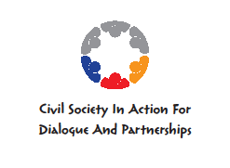

FINAL CONFERENCE, MOSTAR
AGREEMENT AS A BASIS OF COOPERATION BETWEEN CIVIL SOCIETY AND AUTHORITIES IN BOSNIA AND HERZEGOVINA

9 – 10 MAY 2013, Hotel ERO

Within the project titled „Civil Society in Action for Dialogue and Partnership“, implemented jointly by nongovernmental organisations from Bosnia and Herzegovina: Demokratski centar „Nove nade“ (Democratic Centre „New Hopes“) Bihac, Centar za lokalni razvoj (Local Development Centre) Breza; Agencija lokalne demokratije (Local Democracy Agency) Mostar, Forum građana Tuzle (Forum of Tuzla Citizens), DON Prijedor, Agencija lokalne demokratije (Local Democracy Agency) Zavidovići; Croatia: Agencija lokalne demokratije (Local Democracy Agency) Osijek; and Srbije: Agencija lokalne demokratije (Local Democracy Agency) Subotica; financially supported by the Delegation of the European Commission in Bosnia and Herzegovina within the IPA programme of support to theme-based NGO networks, a closing conference of the project was held in Mostar on the 9th and 10th of May 2013.

Invitation to the conference was sent to the trainees of the nongovernmental organisations of the theme-based NGO network, experts and researchers, representatives of local authorities and their associations from Bosnia and Herzegovina, Croatia and Serbia, as well as local media, a total of 115 of them. A total of 73 persons were present at the Conference, of which 69 on the first day of the conference. On the second day of the conference, at the Fair of Nongovernmental Organisations, there were 41 persons coming from 29 organisations from 8 towns.

Prior to the official opening of the conference, the participants saw a 10-minute documentary film, made in towns of Bosnia and Herzegovina which participated in the project.

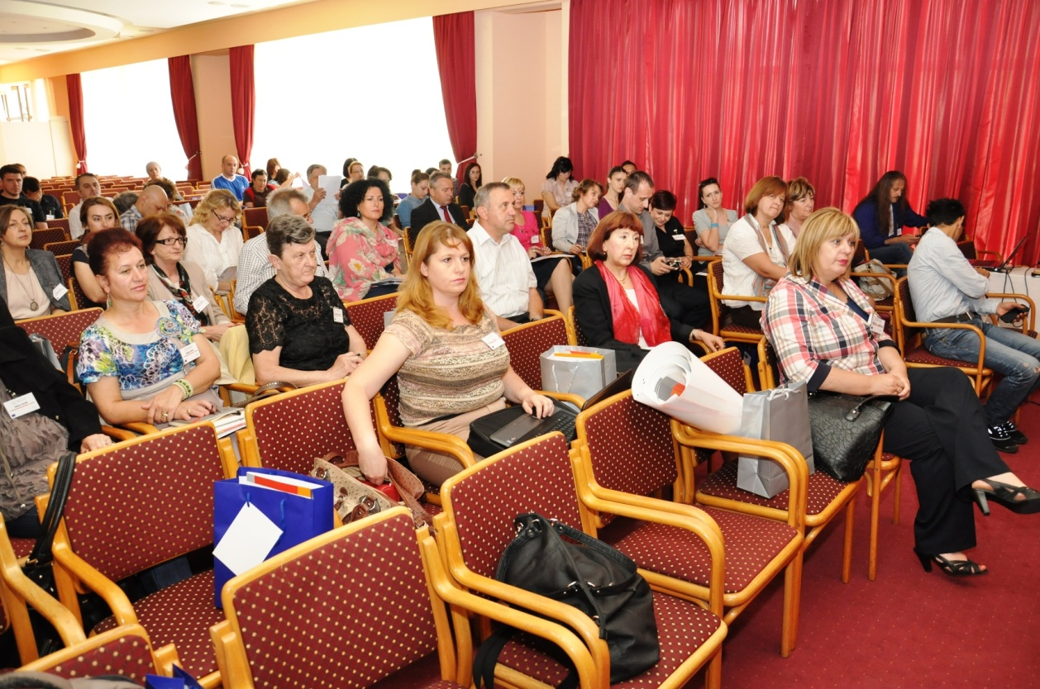
Dzenana Dedic, executive director of the Agencija lokalne demokratije Mostar addressed the participants at the very beginning of the conference. She welcomed the participants, presented the partners jointly cooperating in implementation of the project, and gave the overview of the activities so far completed within the project. The activities presented include: a session held for the civil society organisations in Bosnia and Herzegovina and the local authorities, i.e. towns, associates in the project, four documentary films were made for all towns, several public debates about the implementation of the agreement on cooperation between local authorities and nongovernmental organisations were held, and six electronic newsletters were published. The newsletters were about gender equality, ecology, youth and other topics. A research was published including 24 municipalities in Bosnia and Herzegovina about the situation related to the agreement on cooperation between local authorities and civil society, and the analysis should soon be published. Six address-books of nongovernmental organisations were published, focusing on six towns, associates in the project. The works are currently based on the preparation of professional papers around the central theme of „Municipal agreements on cooperation with civil society in Bosnia and Herzegovina – from memorandum of understanding to local practice“. Mrs. Dedic announced the NGO fair to be held the next day of the conference, as a place where the nongovernmental organisations would be given a chance to get to know each other and to achieve cooperation in the fields of their common interest. Cooperation of the partner organisations in this project is on extremely high level, and this cooperation will somehow continue and institutionalise by signing of a memorandum of understanding committing all the partner organisations to further cooperation in the field of civil society and local authorities.

After the introduction by the host, the participants of the conference were addressed by the Mayor of the City of Mostar, Mr. Ljubo Beslic, who welcomed the participants to Mostar. After the City Council of the City of Mostar adopted the decision on the Agreement of the City of Mostar and nongovernmental organisations of the City of Mostar in July 2012, the City of Mostar and the nongovernmental organisations have established the official cooperation and have created the precondition for access to European and international funds. The mayor of the City of Mostar expressed his hope that the two-day conference would provide true insight into the current challenges in implementation of the European standards for democratic management at the local level, the role of local government in the process of integration into the European Union, as well as the overview of local practices related to the implementation of municipal agreements on cooperation and Bosnia and Herzegovina. At the end of his address, Mr. Beslic wished a successful work to all participants, and a pleasant stay in Mostar.

On behalf of the leading partner in the project, the Asocijacija agencija lokalne demokratije (ALDA), the participants were addressed by Mr. Marco Boaria, the head of the project development department. He presented the ALDA, its mission, goals and fields of activities.

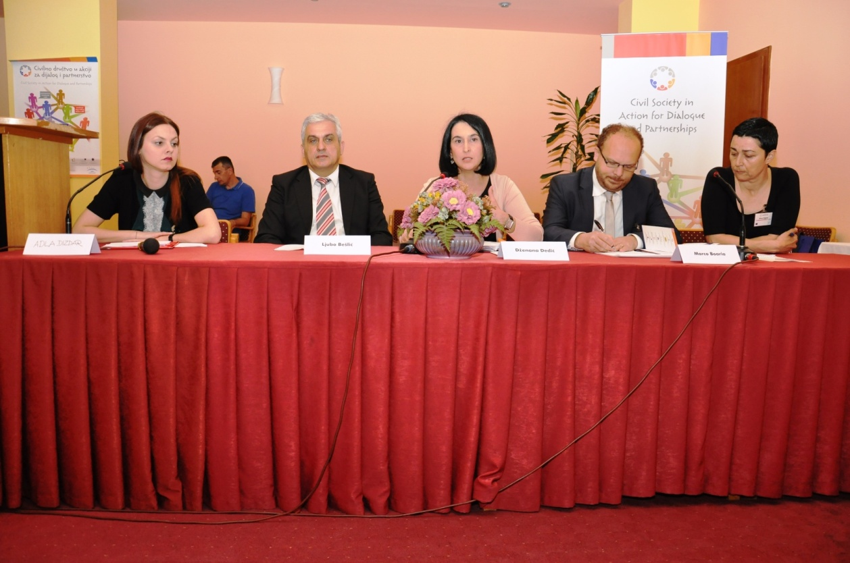

Following the official opening of the conference, the introductory panel was held with the topic: „Cooperation Agreements – from legal framework, to efficient implementation“. The introductory speakers were: Ms. Sadeta Skaljic, head of the Civil Society Department within the Ministry of Justice of Bosnia and Herzegovina, and Ms. Murisa Maric, DON Prijedor.
Activities had been ongoing in Bosnia and Herzegovina towards establishment of institutional cooperation between the authorities and the civil sector, but it was only in 2007 that the Council of Ministers of Bosnia and Herzegovina and the civil society signed an agreement on cooperation, which, in fact, presented the first step in establishment of a new type of relationship between the authorities and the civil society. Nonetheless, not much has been done on the implementation of the agreement itself.

Ms. Sadeta Skaljic gave the introductory presentation titled „Cooperation of Authorities with the Civil Society in Bosnia and Herzegovina“.

The role of the civil society
Ms. Skaljic started her presentation with a reminder on what the role of the civil society is, and thus said that the civil society should be the precondition for democracy, protection of human rights, equality and equivalence of citizens, regardless of their ethnic and religious background. Their power to organise themselves, and specifically their quality of work, determine whether they will achieve such high goals. The civil society includes the overall public space between a family and the state, with different forms and levels of self-organisation, independence, privacy, autonomy and willingness.
Who forms the civil society? Citizens, civil initiatives, civil society organisations, i.e. associations founded on membership, working in the interest of their members or for the general good. They work in the different fields of activities, from human rights, minority rights, youth rights, marginalised groups, humanitarian organisations, sport associations, etc. This also includes professional associations, trade, academic community, and in wider sense – media and religious communities. They are established on voluntary basis with the purpose to satisfy a certain goal which is not of a profit making character.
Why do we need civil society? We have signed the Stabilisation and Accession Agreement and we want to enter the European Union. In all countries of the European Union, besides the representational democracy, there is a participative democracy also existing, made of citizens through different civil society organisations. The goal is to prevent the ruling elite from alienation and separation into a class which cares for their citizens only during the times of elections. It is necessary for any public function to be submitted to the control of the citizens, because they are the ones who established it. It is also necessary for the citizens to become involved in all decision-making processes that concern them. They need to know in what way and in which cases they can address relevant and competent governmental institutions. This is more difficult to do as individuals or in smaller groups. It is far more efficient to act through civil society organisations, and especially when they are grouped in theme-based networks and coalitions.
Ms. Skaljic also cited two negative examples of citizens of Bosnia and Herzegovina not becoming involved. The Federation issued a public call to award a concession for construction of a cement factory. They have chosen the best bidder. The said had the most modern filters, said they would do an access road and employ persons from the local area. Still, as they were in a hurry, they had no time to involve citizens in the process. Afterwards, we have buried the municipality with the protests coming from the citizens from this area, and also the courts with administrative disputes. Believe me, we just needed to take respected householders from this area to see how the filters were positioned (I think it is Kakanj), and I am sure the courts would not be burdened, since we dearly pay judges to do standard procedures, because, at the end, this turned out to be a standard procedure.
The second example is coming from my Ministry, unfortunately. We have done the modification of the Law on Criminal Procedure 18 times. The procedure for modification of a law is identical to passing of a law. Why? Because, those who are making decisions think that division between legislative, executive, judicial authority is strict and they have not involved the associations of judges, organisation of solicitors, association of prosecutors, who are the ones who apply the law and who see in practice what are the methods and how laws are being applied. These are the processes and we are understand, we are aware that without inclusion of the citizens, we will lag behind in these activities.
Civil society is also a source of information for the government, who finds through them what is it the citizens want and expect from their state. A state with a developed civil society is a politically stabile country, more pleasant for life for their citizens, because the citizens' freedoms enlarge, the rule of law is promoted, corruption is decreased and larger and more efficient government is established. Therefore, the civil society is a precondition for citizens' equality and democracy, regardless of the national and religious background. If the principle of equality before the law is disrupted, there is an opening for authoritativeness, intolerance to differences, and this leads into inclination to use force to solve conflicts. The civil society should represent the idea that the time of leading peoples, religions, ideologies to the detriment of others is in the past. We, people from Herzegovina, and specifically us from Mostar, used to be the example of multiethnic and multicultural society. We need to stand together now, too, and to embrace personal freedoms only to the limit of the freedom of others, to avoid phenomena of the saying: divide and rule. Mutual appreciation, respect, tolerance, appropriate distribution of assets, present the precondition for prevention of conflicts. Regardless of differences, we depend on each other and this is our obligation to carefully see where these systems of value have been violated. The life on Earth, the civilisation as a whole, are in danger, until we learn to live together in respect and understanding. We are all responsible for this country and we must put an effort to truly achieve real democratic principles within the scope of what we do and where we are. Joint destiny demands from us to solve problems together, because we will be endangered otherwise.
Civil society, in cooperation with the institutions and international community, must put an effort to develop effective mechanisms, to develop the rule of law and equality before the law, because it is important to research and to find causes which lead to the disturbance in relations between people and states. Civil society should find the culprits and warn about their existence and propose the measures to neutralise their activities. Extreme nationalism, which, unfortunately, still exists, is present in the form of hate towards the other peoples, and it was the trigger of the war in this area. The civil society should argue for putting restraints upon the exclusivist nationalism through impact on national and international law and it should represent the justice which respects the equality of the peoples. These are the principle of a good civil society which, unfortunately, does not have a sufficient cohesive force, mutual solidarity to take it towards the results to have a crucial importance for faster and better breakthrough with the aim of a better life for the citizens of Bosnia and Herzegovina and to speed up the processes of European integrations.
Poor civil society significantly reduces the contribution of good, by violating the rules of behaviour, inciting hatred and intolerance, because they are the extended arms of the nationalists (sport fans, radical nationalistic movements).

Cooperation of authorities with the civil society
As one journalist said (cooperation of the authorities with the civil society) remained on paper, alluding to the Agreement on Cooperation between the Council of Ministers and the NGO sector, signed in May 2007. Regardless of the fact that I am known for being critical, I can not fully agree with this statement. The agreement on cooperation between the Council of Ministers of Bosnia and Herzegovina and the NGO sector was, indeed, made at the initiative of the civil society, where both parties committed to significantly supporting the civil society by establishing an office for cooperation with the civil society at the state level, a council as a body made of the most influential representatives of both authorities and civil society, transparently distributing the funds from all levels. The crisis has impeded the implementation of the agreement, but still, some things were done.
The agreements have been signed, as we heard, in many municipalities: a Department of Civil Sector was established within the Ministry of Justice in 2008, and it has been given the same authority as those given to the offices in the surroundings. The truth is that we do not have a rule of a resource centre, we can not influence others. Our role is to create an environment which is simulative for the development of the civil society through advisory and informative activities, and to propose the laws related to the civil society. Recently, our law on volunteering was passed.
At the moment, we are working on the Strategy for creation of a simulative environment for development of civil society together with a working group which has been, for the first time, composed of the members of the strongest civil society networks. Surely, there are also five representatives of the institutions at all levels, the working material was prepared and although the entities, based on the Constitution, are in duty to help us in the implementation of international obligations, we have been obstructed by the Republika Srpska.
Besides significant funds allocated at all levels for the civil society, from the local community to the state, there is a significant legislative framework present. Believe us that we have been the first to pass the Law on Freedom of Information in 2002, but even after more than ten years of its implementation, its primary function in development of democracy and good governance for the benefit of the citizens of Bosnia and Herzegovina, as the bearers of the right to freedom of information, has not been fully established. This is supported by a large number of complaints; more than 260 submitted to the Ombudsmen Office at the level of Bosnia and Herzegovina. We have also been the first to bring the rulebook on consultations when developing legal regulations since 2006, by which the participation of citizens in the processes of creation of public policies and laws was ensured. Nonetheless, successful application of these rules requires a larger interest and education of the civil society, but also a more responsible application by the institutions. The Law on Ban of Discrimination, on gender equality was also passed, with a large contribution and in cooperation with the civil society. These mechanisms, provided by the law, should be used and this requires a responsible and active citizen. I think that the role of independent media is very important and it is very significant. The media is an extended part of the civil society, but, unfortunately, the cooperation is still not on the right level. We also have four laws on associations and foundations. They are liberal, they provide relatively simple registration procedure. Nonetheless, it is being done by 13 registry bodies. This is really unnecessary for such a small country as ours, and it creates an unrealistic picture about the numbers, because many of them register at more than one level. The Law on a Unique Register, which could have made significant changes, was rejected by the Parliament.
Generally, the situation of the civil sector of Bosnia and Herzegovina is not satisfactory, and this is particularly so when compared to the region. We have joined the Ljubljana Declaration in 2008, and have committed (us, from the Western Balkans and from Turkey) to cooperate in even development of civil society through an informal triangle: national governments, European Union delegations in these countries and civil society, adjusted to the situation in each of the countries. A while ago, we were the leaders in the region and the representatives of our civil society held trainings for others. Nonetheless, due to different obstructions, we are significantly falling behind now. Namely, we regularly meet and exchange information, and it is not pleasant when you hear how much others have achieved, and we are not being allowed to. Trust me, since 2008 we had meetings in Ljubljana, Zagreb, Zadar, Skopje and we are now going to Pristina. We were in Ankara and, believe me, a while ago we were the ones to talk about things before. Unfortunately, we are now falling behind in many things, because most of these countries are already preparing the second strategy on creating a stimulating environment. They have quickly caught up. I am telling you – we exchange experiences and I am very uncomfortable when I have to come to such a gathering and speak about the same things; the things done a while ago and no progress to be seen. The number of civil society organisations mentioned in some publications, reaching up to 12,000, is unrealistic. Surely, at best only a half is active.
One of the main reasons for this is the division of the country by ethnic and religious lines, which has disrupted the development of the BH identity, which presents the fundament for the development of civil society. The reason for this is in the lack of sector-based approach to the identification of the problem and, in general, creation of the political systems to define priorities and proposals for overcoming of the occurring problems. This is mainly related to the lack of strategies at the level of Bosnia and Herzegovina; social, health, education, employment and other strategies. A large problem lays in the implementation of the rules from Copenhagen, which require from each country to establish appropriate state-level institutions as permanent addresses for each of the fields. This would make it significantly easier for the social sector to keep the pace with the processes, and would ease the processes of the European integrations. Special attention must be paid to the IPA 2014-2020. These are the funds foreseen for the Western Balkans, Turkey and Iceland. These funds are unique and dependent on the fact whether the country has a strategic document for the given field. In order to make a strategic document, it is necessary and compulsory to include the representatives of civil society in these fields. This is sine qua non and it can not go without it. Thus, we have to have the strategies. We must have representatives of the civil sector in making the said documents, because the funds will be allocated only to those who have completed all the tasks. From the Ministry of Justice, Civil Society Sector, we have together with the Directorate of European Integrations, the Delegation of the European Union, with the support of the European Union – TACSO, sent the invitation to the civil society organisations to elect new representatives for participation in these activities and to be prepared to what is expected from the 2013, since we will not be able to apply for the funds, even if we have the best projects, if we do not fulfil the requirements.

Conclusion:
Along with all the difficulties, the civil society can not respond to the growing social needs tied to the transition processes in the society, from the conflict to the stabile peace. Still, the most significant cause of such a situation is in the political obstacles and insufficient capacities of governmental and nongovernmental sector for quality implementation of the cooperation mechanisms.
The problem is also in lack of communication among the civil society. Although the number of networks is on the rise, they unfortunately, often have individual purpose, i.e. providing funds for ad hoc projects from a number of donors, and they are usually of unsustainable nature, and after the end of the project, their activities are put down to the minimum.
I hope that this project will continue and I see it has potential and capacities for that. It is therefore very important for us to have such conferences where we can view the situation, exchange opinions and help one another to develop this significant segment of the society and catch up with the countries in the region. It is clear to us that the civil society is very importnat, but it is not a magic wand to solf all problems. It is just one of the protagonists.

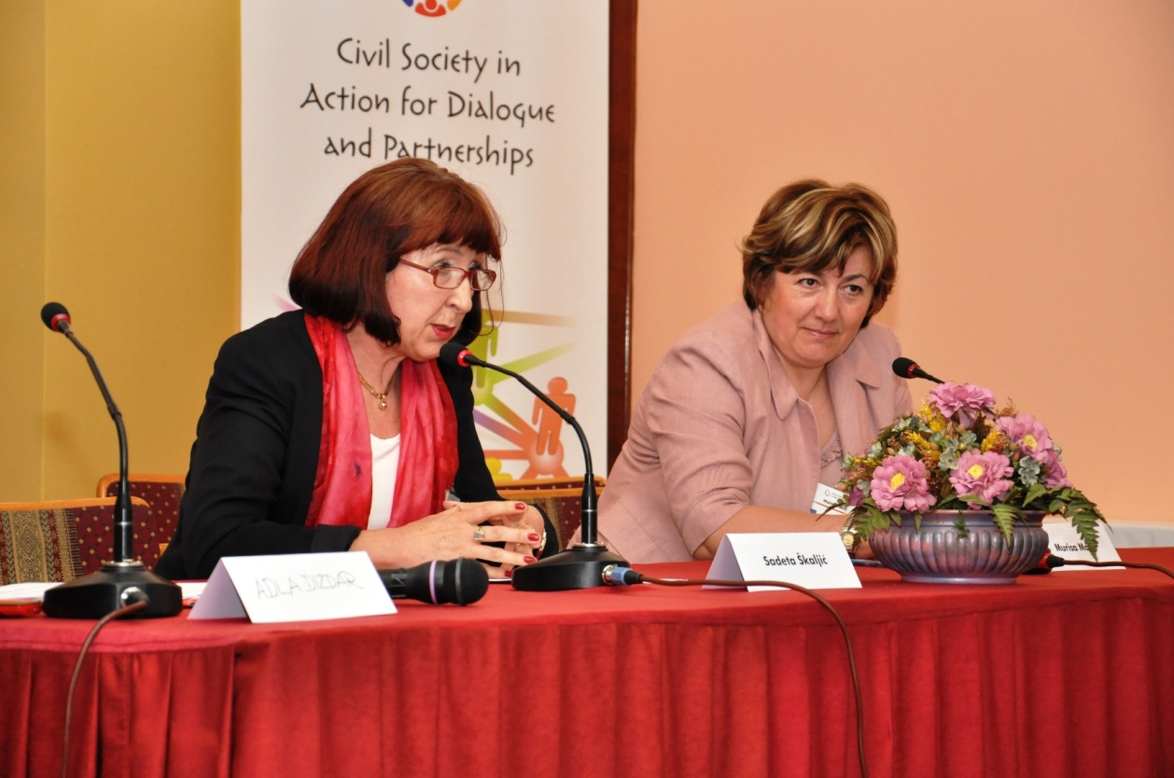

Ms. Murisa Maric, the director of DON Prijedor, gave an introductory speech about “Challenges and Perspectives for Development of Civil Society”. We heard from Ms. Skaljic how the Government perceives what should the civil society organisations do, and one thing we have been working on for the last ten years is in fact the creation of dialogue, and only then the partner relations between the two sectors. For about four or five years, we have only been working on reaching the first agreement, signed in April 2007. It still presents a challenge, and I think we will be able to perceive today whether it is a perspective, too. It has been six years since the agreement was put in place, but it is still one big challenge for all of us from the civil society. This is especially so because we have been recently faced with the civil society being mentioned in a rather negative context. This does not contribute to the importance of the development of the civil society as a precondition for the development of the overall society. We are the witnesses of what is happening to the Centres of Civil Initiatives. We are the witnesses of what has been going on with the civil society organisations in the Republika Srpska, and us – people from the civil society sector – wonder who will be next. Is his really the challenge for the dialogue, and later on for the partnership? When the civil society organisations started developing, in the 90s and even more during the war, we have been working on humanitarian aid and protection of human rights. I think that we have not moved much from there; it seems to me that we are still speaking about humanitarian aid and that we have not crossed that line, have not moved further. We need to question whether this is our perspective and we need to see how far we really got. To what extent have different protagonists impacted this, and we are the witnesses that there must be two sides for the dialogue, it can not be a one-sided thing. The time has come for something to change, to move from a standstill, because we have been moving in circles for many years. Two years have passed for these organisations, gathered around the project “Civil Society in Action for Dialogue and Partnership”. The title itself says that we are still in the action for a dialogue, that this dialogue must have some duties and that we must move forwards with the assistance from many relevant civil society organisations, but also from the representatives of the government. This responsibility lays on both sides, because we are public, we are responsible for the future of this country and we really have the same responsibility, regardless of the fact whether there is a strategy or not. The organisations are working, doing their part of the work, and what is happening to us? Several challenges we defined through our process are really very important and we will have to get answers to them; not only between us, but also in a dialogue with the government. Of course, we can not leave the international community out from this story. One of the big challenges to the support to the development of the civil society is surely the European Union programmes, and specifically the pre-accession assistance. Is this is a programme only for the privileged – several tens of organisations who had been lucky to be a part of the institutional strengthening education programmes? There is only a few of us who strengthened their capacities to be able to take on the European Union funds and to participate in the IPA programmes. What about the remaining 11,800 organisations who also need this assistance? Can we influence the IPA programming, have we participated in the 2014-2020 programming, is the voice of the civil society heard when it comes to the needs? Not running away from our responsibilities, but I think that the local events are not in the offices of the local administrations, but on the field, the field where the civil society organisations are operating. A great challenge is in the IPA funds, and there is also a challenge as to how to reach the part of the co-financing, when we do not have the dialogue on that level, nor the cooperation with the local administration to provide sufficient funds to be a part of this European story.
Another very important challenge is the role of the governmental institutions in creation of transparent framework for financing of the civil society organisations. The research we are implementing, the one that is still ongoing, covers some 30% of the local administrations which have, but also those that have not signed the agreement on cooperation, but they all have funds allocated for the nongovernmental sector and they are all granting the funds to them. More than 10.5 million KM were allocated for the nongovernmental sector last year in only some 20 municipalities. Out of these funds, not even close to one million KM were allocated to the civil sector, while 7.5 million KM were allocated to sports. In the part where we asked to see the level of application of the agreement on cooperation, justification of funds, reports and all others mechanisms are still without any control, and local institutions are not even trying to establish them. Therefore, our agreement is still a large challenge and a perspective for the development of the civil society in order to put this to the level where we both would be content, and specifically because the local communities have much more problems than just sports. Anyhow, the story has to start taking another direction, with the responsibility of both sides. You know the importance of coordination between international organisations who donate funds in Bosnia and Herzegovina and we have been witnesses in the past two years of having many donors focusing their funds to specific areas and there is a huge imbalance in the country when it comes to coverage, funds and the development of the civil society, which is something we need to work on together. The challenges area also in the financing of civil society organisations and the support of the local community is lacking in a number of cases because the funds ranging from 30,000 to 100,000 KM for the projects allocated in the local administration budgets are sufficient only for the purpose of preserving the social peace and to linearly share these funds for, let’s say, 30 organisations receiving 1,500 to 2,000 KM each. These are not the projects which can provide sustainable development of the civil society and achievement of results. It is for this reasons that the organisations are now opening small and medium businesses, and then we have another question – where is our civil sector going and whether this situation forces us to be partially profitable and partially non-profitable organisations in order to provide co-financing? This is because the profit will return either for financing of the organisation or to provide 10-15% of the co-financing we need, but are we losing the characteristic of the civil society which we stand up for? According to the signed agreement, the issues about the creation of the legal environment for the civil society organisations, we are the witnesses that the changes of the law, as Mrs. Skaljic said, are equal to passing of the new laws and this process is taking a slow pace. Unfortunately, us from the civil society organisations, recognise that our laws largely do not suit the real needs. The very fact that three persons establish a civil society organisation led to such a large number of organisations, and we still have no control mechanisms how to check the organisations that do not work and, as it is stated in the law, whether they have closed their operations as stipulated by the law. The responsibility in this segment is, again, on both of us and we should take care of this, and this goes specifically for the representatives of the local administrations. Are there 12,000 organisations? The fact that there were more than 4,500 organisations with the end of 2011, in November, as stated on the Government’s web site, means that the figure of 12,000 is very realistic and that there is a larger number of organisations in the other entities. If these are the organisations registered, how many of them are active presents a different, very significant question. Another large challenge for us all is how to create a balance between the institutional support by the governmental institutions, and our political and budgetary independence. In order to receive co-financing from the local administrations, we become dependent on a regime and we are pushed into this process by the letters of support we must provide to start with implementation of any project. This support is mostly conditioned by the international organisations and by this the civil society loses its point; being a critical review of anyone’s work. By giving the support by the local authorities, there comes a certain expectancy of loyalty. The same goes in terms of criticising, as if we receive something from someone, we should not criticise them, and this is not good for the civil society. So, this is where we, from the civil sector, must see how to get the letters, if this is one of the preconditions, but to remain independent and to avoid having a political game at the expense of the good work of the civil sector organisations. The monitoring is definitively the weakest point of work for governmental, but also nongovernmental organisations, because the projects are usually implemented without looking into their future, without following up on what happens after us. Of course, this does not go for all, since there is a large number of organisations which can surely respond to this, but we need support in this segment. As for the governmental sector, there is definitively no monitoring in any segment, and specifically when it comes to allocation of funds through project activities of non-profit organisations. If you have no feedback on where your money went, if you see no progress and if you finance the same things for years, then there is something wrong there. The civil society organisations, essentially, did not aim only for financing of the civil society through this agreement, nor was it the only precondition of it. Still, somehow, when we talk about it, we reach the understanding that this was the only precondition. There were many segments included in the agreement and they do not exist today from neither side. The motivation for the work of the civil society organisations and our fight with windmills has been taking too long. There is a certain progress, but is still invisible in the long transition process. The transition should end at some point, and this one we are going through is taking too long, and it seems that we are still at the very beginning. The importance of the dialogue was visible through the process taking place in these two years. All of us, representatives of the civil society in Bosnia and Herzegovina, but also our colleagues in Croatia and Serbia, thing that this is a continuous process and the dialogue will never end and it should never end. Simply, we must move the limitations from this unenviable level, and we have to provide citizens’ participation in a more lasting way. Destroying what we took from the system in which we had lived until the 90s, which is our main unit within the local communities, where we had at least some part in the decision-making process, disrupted the trust and understanding as to where citizens could really participate in something. Citizen’s participation has transferred to the election process, when we make decisions about the 30 something people who will make decisions on our behalf in all of the processes. The elected representatives need to return to the voters / citizens, but the situation of today shows that there is no inclusion of citizens and when it comes to consultations they are very weak and they start when the documents have already been defined and brought on a certain level, and then they consult us and we mostly never receive any feedback as to what was our participation in it, whether these public debates have any sense since they are only a legal format, and to what extent is everything pro forma because Bosnia and Herzegovina has signed certain declarations and has to do something. To what extent has the TACSO programme of support aided in returning the process to the level of dialogue and having the voice of the civil society organisations heard, is seen by all of us in Bosnia and Herzegovina. Of course, TACSO is not only in Bosnia and Herzegovina, but also in the surrounding countries and there is a dialogue, but is the dialogue all that we need or should we ask and demand a higher responsibility from the other side. If we brought certain conclusions, are we partially obliged by that? We have witnessed the importance of the critical public because the discussions about nongovernmental organisations started. Are we really partners? I think we still are not. Has our work been recognised as something important? I think that we are witnesses that it has not been recognised. We can not say that for all towns or institutions, or anyone, and can not say that there is no progress, but 10 years of the struggle about the agreement and its application says that the fight for the status of the civil society will not end. The agreement has been signed in about 50% of the towns and cities. The agreement is a large challenge and the perspective in the future work of the civil society organisations, but also the governmental organisations. A large number of challenges for the civil society have been recognised in these two years, and I am sure the colleagues who were not directly involved in the process will agree with me, and these changes are important for all of us who work for the benefit of the citizens of our country.
At the end, let me say that we have seen in Prijedor that not everything is black and that the work of the civil society organisations is recognised and even maybe valued. This year, for the first time in a large number, the civil society organisations were nominated for the award of the City of Prijedor, awarded every year on the 16th of May. By the unanimous vote of the City Council, some 10 days ago, the Association DON, received the award for its work and this is maybe an incentive and a motivation for all CSOs to see that our work is recognised and valued. I wish to share with you not to brag about the award itself, but because we have really done a lot in the last fifteen years. We at DON think that this award came at the right time when all of these attacks on civil society are taking place. If it is a stimulus, it is important that the civil society organizations are recognised in at least one city, showing that they are doing their work for the benefit of the citizens.

After the introductory speeches of Ms. Skaljic and Ms. Maric, the project partners signed a regional agreement of cooperation committing them to further work on these issues. Of course, all civil society organisations working on these issues or interested to do so are more than welcome, because the more of us in the process, the better the result of it.

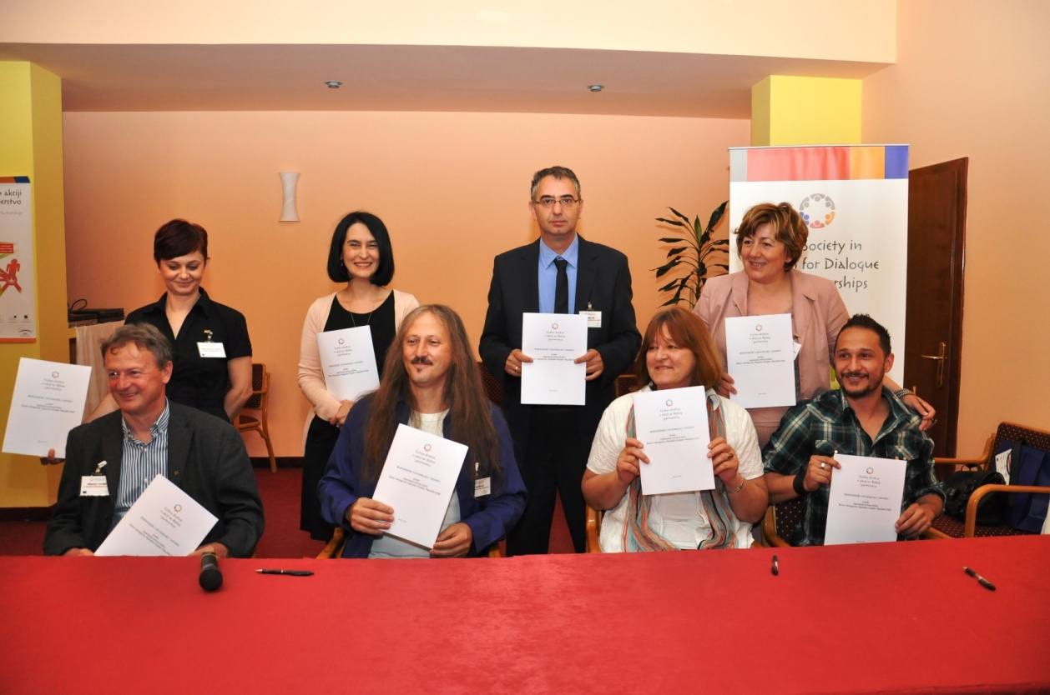

Parallel panel sessions were held after the signing of a regional agreement on cooperation between the project partners. The first panel session, “Implementation of General Agreements on Cooperation and Thematic Networking in Bosnia and Herzegovina”, was moderated by Emina Babovic Gojacic of the Forum građana Tuzle, and Murisa Maric of the Don Prijedor.
During the war conflict in Bosnia and Herzegovina, due to war circumstances and the lack of capacities of the authorities, many of the nongovernmental organisations took over some of the governmental functions, which carried on after the war, too. Thus, today, we have nongovernmental organisations dealing with victims of domestic violence, who are being accommodated in the so-called “safe houses”, which should, primarily, be the function of the state. This example clearly shows that the cooperation between governmental and nongovernmental sectors should exist, that it should be strengthened through joining of knowledge, capacities and funds, in order to provide the citizens with the services for which there is a realistic need. Some 50% of the municipalities in Bosnia and Herzegovina have signed the agreement of cooperation, but what does this agreement really mean? Is it only a paper or is this cooperation really functioning somewhere?
Within the project “Civil Society in Action for Dialogue and Partnership”, there was a research conducted including 24 municipalities (presenting approximately 30% out of a total 142 municipalities in Bosnia and Herzegovina). The results of the research show that the majority of interviewed municipalities have defined the persons who would be contacts for cooperation with civil society through different portfolios or as independent expert associates for cooperation with the civil society, which makes a certain progress in relation to the situation in 2007. The majority of the municipalities have international certificates on standards, which are usually related to procedures, and there are no indicators to justify those certificates. The majority of the local administrations included in this research do not have teams for project writing, who would draw the accession funds of the European Union. This job is put on the development agencies, which should, in fact, be dealing with economic development. Although the agreement on cooperation between governmental and nongovernmental sectors at the local level foresees planning of the fields of activities to be funded by the local administration in the upcoming year (based on the evaluation of the past year), the research has shown that such planning is not being carried out, but the financing is allocated to all fields of activities within the social range. A large amount of funds at the local level is allocated to financing of sports (the funds are even larger than the funds the European Union will invest into Bosnia and Herzegovina through the IPA funds). Devastating is the fact that a large number of municipalities do not have defined procedures for reporting on granted funds, nor are there any registers of organisations active in the local area (with the exception of a few municipalities who have the register of youth organisations).
After brief introductions, the moderators opened the discussion and invited all participants to take an active part in it and to share their experiences from the municipalities they came from.
Slavica Draskovic, of the TACSO BiH, emphasised the importance of such a research, since it treats the issue of the agreement on cooperation’s implementation at the local level deeply and essentially. The second research done within the TACSO project also related to the nature of contribution which the local administrations give for the projects as a contribution for participation of the organisations. This research is available in both local and English languages at the web page www.tacso.org and it shows that there is no real partnership. It lacks even the first word – the dialogue. The partnership is questionable because the local administrations take late involvement, even when they give money. We can not talk about the true partnership, growth and developments the civil society organisations and their personnel go through, because they implement the project and learn, for as long as the other side falls behind on the learning part and thus there is no partnership. How can the other side learn if they do not participate? The TACSO’s report shows what are the other shortcomings, based on what Ms. Maric said – where are the development centres within the municipalities? If we start with the dialogue and establish partnership, then our projects will really be in the function of the community’s development, because the other part of the community will say what is important through the strategic positioning for the next year. The results of the TACSO’s report converge with the preliminary results Ms. Maric presented.
Sefika Muratagic, the executive director of the NGO “Kljuc buducnosti” (Key to Future) from Kljuc, stated, but also made an appeal to the colleagues from the nongovernmental organisations, that the same nongovernmental organisations are rarely calling upon the agreement when implementing their activities. Small is the number of the organisations who dedicate a part of their time, voluntarily, to contribute to the implementation of the agreement at the local level. Ms. Muratagic states that should the nongovernmental organisations dedicate a part of their time, and if modifications and amendments of the agreement are made, both sectors will largely benefit along with the final beneficiaries – the citizens. In the area of the Kljuc municipality the implementation of the local agreement on cooperation between governmental and nongovernmental sector is not ideal. Nonetheless, they had the support from the local community and made modifications and amendments of the agreement which are very useful. Still, not much further was achieved. Ms. Muratagic thinks about starting an initiative to prepare an action plan for implementation of the agreement on cooperation at the local level, as well as for passing certain modifications and amendments which are necessary because the basic agreement has already become a narrow frame for both governmental and nongovernmental sector. The citizens should be included in the whole process, whether they are gathered around nongovernmental organisations, or they are those who want to develop to the development of partnership relations and improve their participation in the very decision-making process on developing of a community. Still, the agreement itself provides a number of opportunities for cooperation between nongovernmental organisations and the local authorities.
Murisa Maric emphasised that one of the goals of the the research implemented within this project was to animate the public, i.e. nongovernmental organisations to take action, to change things to provide cooperation with the local authorities. The initial agreement stated that the local community would provide 49% of funds for implementation of a project should the nongovernmental organisation secure 51%. Should the nongovernmental organisation bring a project of 100,000 EUR value to the local community, will any local administration provide another 49%. The agreements were signed without discussion about this, which means that us, from the civil society organisations, are to blame for not using all available mechanisms to implement the agreement in the way it was written. The agreement says that should the nongovernmental organisation bring 80% of the funding, the municipality should provide the remaining 20% and this is something they signed. Has any of us ever addressed the local administration and wrote: “In accordance with the agreement from 2009, you have accepted to provide 20% of the co-financing for a project if we bring 80% of the funding to the local community?” No one. Nongovernmental organisations do not use the agreement to reach funds for co-financing, and we resort to all alternatives instead of using what we should be using. Co-financing is not foreseen in the budget, meaning that the agreement came as something we need, and it was as such accepted by the local administrations. On the other hand, if it has been signed, it is up to us to advocate for it to be implemented in practice, because we had not made them sign it. If they had signed such an agreement, copies of which we all have, then we should gather in the dialogue in the first place.
Emina Babovic Gojacic stated the fact that five municipalities have been involved in this project as associates, but their participation in the implementation of the project was at a very low level, bringing us to the conclusion that such cooperation does not reflect the principles of true partnership.
Samir Halilovic, of the Demokratski centar Nove Nade (Democratic Centre, New Hopes) from Bihac, thinks that the civil society is a constitutional part of the society of Bosnia and Herzegovina. We have a business sector, governmental sector and nongovernmental sector. Do we have two sectors that have not been organised? Yes. Does the business sector have an agreement signed with the governmental sector? No. In our society, we lack an organised civil sector, who finances it, who are the people who work in it, who are those professionals, what is the infrastructure they rest on, etc. Not one agreement will solve these issues. This state does not wish to have an organised civil sector, a quality sector, etc.
Drago Martinovic, from the Siroki Brijeg Municipality, an advisor to the mayor on public relations, got an impression from responses of the nongovernmental organisations participating in a research he implemented in ten local communities – centres of cantons (BIhac, Orasje, Tuzla, Zenica, Gorazde, Travnik, Mostar, Siroki Brijeg, Sarajevo and LIvno), and in Republika Srpska (Bijeljina, Prijedor, and Banja Luka) that the cooperation with the local communities is good, and some places even excellent (e.g.: Sarajevo: Institut za mlade „Kult“ (Youth Institute Kult); Banja Luka: Association of Women) . The truth is that the nongovernmental organisations are not calling upon the agreement when attempting to have cooperation with the local administration.
Sabina Memic, from the City of Mostar, department of community activities, is working on the issues of cooperation of nongovernmental and religious communities in the City of Mostar. The local community, as one of the primary frames of the state, should support and initiate the civil society, and thus, the governmental and nongovernmental sectors are partners. Us, at the City of Mostar, try to implement this partnership and be the partners in the society.
Brankica Davidovic, Udruzenje za pomoc mentalno nedovoljno razvijenim licima (Association for Support to Mentally Impaired Persons) Prijedor, emphasised that the cooperation with the local community in Prijedor does exist, but it is not on a satisfactory level. The preliminary results of the research Ms. Maric presented today are „a push“ for us, as nongovernmental organisations, to impose ourselves to the local community with our problems. The letters of support signed by the local administrations often worry us. Not in terms whether we will get them or not, but because we do receive them, but when it comes to implementation, we wonder what to do.
Mirjana Penava, from the NVO Forma F (NGO Forma F) Mostar, stated that we lack cooperation with the local authorities with the goal of analysing the needs on the field, including rural areas and thematic sessions to be utilised for development of rural areas. She agreed with Ms. Memic that there was no cooperation. Nonetheless, the governmental organisations from Mostar will agree that there are other organisations in Mostar apart from the Vijece mladih Grada Mostara (the Youth Council of the City of Mostar). I think that besides the signed agreements, we should work on precise things and we can not be satisfied until we sit down together at the table and until we create joint programmes.
Murisa Maric emphasised that five local communities signed the letters of support for us to enter the implementation of this project. Prijedor, as a municipality, did not sign the letter of support, DON did not receive it. We are still implementing the project in Prijedor, and you heard that we were awarded with the Award of the City of Prijedor. You can decide yourself, how do we make a link on cooperation and lack of it. We really have cooperation. On the other hand, the local administration monitors our work because we made them follow us, because they receive our reports, because no strategy or any other document in our city is made without a representative of DON. We have made them take a different approach by our work. Still, we have not received the letter of support for this project, and this is the first project that came to Prijedor from the pre-accession funds. How do we talk about the partnership when someone did not understand what is this process. Not the mayor, but the staff working with the nongovernmental sector. Another dilemma before us – initiation of the work of the civil society. When it comes to the local institutions, they have never, and will never in the future, initiate the work of the civil sector, because that does not depend on the local administration. Each critical review is closing the door in front of the representatives of the civil society. As much as the local authority is public, the nongovernmental sector is public too. The dialogue is a critical review of some events, but it also goes two-ways. We have not criticised only the local authorities today. We criticised ourselves too. Still, when we sit down with the representatives of the authorities, regardless of the segment we are discussing, then it happens that the representatives of the authorities tell us that they did not come to be preached to. The civil society does not exist to preach, but to help to move forward. For all that the local administration can not do, they have an extended arm in all of the countries except ours.
Suada Softic, an expert advisor for the development of civil society at the Bihac Municipality, has largely agreed with the presentation of Ms. Maric. She is right for most of the things when speaking about the relationship between civil society and local community. When the nongovernmental organisations ask for funds from the local administration, it is usually directly from the major. Good projects should be supported. Cooperation is needed. Out of 200 nongovernmental organisations in Bihac, according to my database, I know only a few of them. I can not make decisions about the money. It is known who makes the decision about the money, but I can give the letter of support, I can come to a workshop if you invite me, etc. We are a politicised society and until that change, many things will not be changed. At the same time, I agree that there should be public calls for allocation of financial means to the civil society organisations and those who prepare good projects will receive the money. Still, there is a large problem with veteran associations to whom you must not avoid giving the money, because that immediately causes a revolution. Local community can not do a revision of civil society organisations, this needs to be done by the civil society organisations.
Muharem Lipovaca, Udruzenje roditelja u borbi protiv zloupotrebe droga “Ruka ruci” (Associations of Parents in Combat Against Drug Abuse “Hand to a Hand”) from Bihac, stated that they have a good cooperation with the local authorities because they don’t ask money and don’t submit reports, either. Out of 12,500 nongovernmental organisations in Bosnia and Herzegovina, a half of them exist only on paper. Out of the other half that does something, I split them in three groups: the first group are those nongovernmental organisations, such is mine, that bring money in the local community. Others are political pets close to the major, and the third are the profit-making organisations. In Bihac there is an annual allotment of about 400,000 KM for certain nongovernmental organisations. They have told us that there would be 85,000 KM available; 50,000 KM for veteran organisations, and 35,000 KM for others.
Sefika Muratagic has repeated that the nongovernmental organisations need to call upon to the agreement and ask adequate modification of the agreement and that they don’t need to cause any rebellions by the governmental or nongovernmental sector. The Bihac Municipality has signed an agreement saying that the funds for projects and activities implemented by the nongovernmental organisations are allocated only through a public call or by co-financing of projects should the nongovernmental organisation secure 51% or 80% of the funds (where the change occurred), i.e. through the projects for which reports are made. There is no financing, “idling” for veteran or any other organisations. Therefore, we will not join up against someone, we will not negate rights of the members of veteran associations. Unfortunately, in the Kljuc Municipality, the „idling“ is financed for the veteran associations. The secretary of the Association of Sport Organisations has been having the salary larger than the mayor’s for years, because 70,000 KM out of the modest Kljuc Municipality’s budget is allocated for the Association. This comes only from the Kljuc Municipality budget, and add to that cantonal and federal levels. The mayor and the municipal councillors noticed that only this year. Why not make the sport association and other sport groups to apply for projects, to justify the funds. This is why I had said it at the beginning: I appeal for adequate implementation of the agreement and this solves a large portion of the funds, without fighting for it.
Marija Radakovic, from the Udruzenje zena “Rudarke” (Association of Women “Rudarke”) from Ljubija said that all of the complaints that are being raised are justified, but we have to understand that we are a society in transition and this is taking a long time. Surely, we are all impatient waiting for it to move faster, to be better, but we have to be satisfied with what has already happened. In order to become the real civil society, we need a lot and it does not happen easily. It seems to me that everything that is fast is not equally good. I think that we are on a good path and that this will go as it should, but we need to be patient. Those in power and those a lot depends on have secured their future and they sit with good reasons there, not allowing anything to change because that suits them. If that could somehow change and if they would understand what our role is, they would be happy if we could talk to them nicely and tell them everything we think about. The changes would then be faster and they would be more satisfied with their work. People would be more pleased with them, and they might stay in power for longer.
Alija Bikic, Vijece Mladih Grada Mostara (Youth Council of the City of Mostar) stated that some nongovernmental organisations still submit their reports to the authorised institutions, e.g. Vijece mladih Grada Mostara submits their report to the Department for Community Activities of the City Administration of Mostar, and they have excellent cooperation with them. Each organisation with a good project can apply for grants that are being awarded and which can be received if the project is good, because no one in the world will give you money for your project if it is not good.
Dzenana Dedic, from the Agencija lokalne demokratije (Agency of Local Democracy) from Mostar has closed the first panel session by saying that whenever we talk about the cooperation between governmental and nongovernmental sectors, these talks always end up in talking about the money. I know that everyone needs money, but it is not the only cooperation and the only bridge between us and the authorities. In Mostar, we had our famous “Mostar Platform” which was an informal group of organisations of the civil society which had meetings with the department of the City Administration in charge of cooperation with the civil society organisations and our meetings, more-less, ended up with this topic. It was about making a plan for allocation of funds, etc. I do not say that it is not needed; it is necessary for us all to live and work, but there are other things we can cooperate on. Precisely, through this project, I have today mentioned the address book of nongovernmental organisations we did together with the Department of Community Activities of the City of Mostar. There are other approaches by the government and by the nongovernmental organisations. I will give our example again: we did a project which really involved the councillors of the City Council, and half way through the implementation the president of the City Council changed. We scheduled a meeting to visit him and introduce ourselves to secure the continuation of the implementation, and he started the meeting with the following words: “I am sorry, but we have no funds in the budget…“ Basically, his assumption was that we came to look for money. We explained what was the reason of our visit, that we did not seek money, on the contrary – we brought it to this community. We are not the ones who only ask for money.

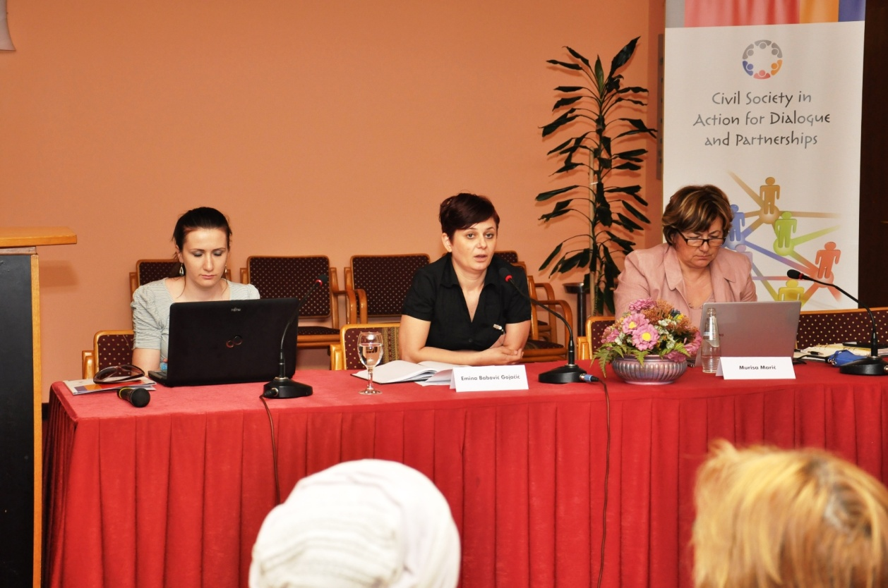

Conclusions:
- In the municipalities which signed the agreement on cooperation between governmental and nongovernmental sector at the local level, this agreement is being consistently implemented
- The procedures for awarding of grants to the civil society organisations implemented by the local authorities should be more transparent.
- The civil society organisations have expressed the need for all the civil society organisations to be treated in the same way, i.e. that some categories of the civil society organisations do not receive funds directly from the budget, but for all organisations to equally participate in public calls published by the local administration for the award of grants.
- Dialogue and partnership between governmental and nongovernmental sector does not understand only the financial support, but dialogue and partnership should include many other forms of cooperation except financial, which, unfortunately, is not the case.

The second panel session, titled “Efficient Actions and Provision of Services of the Local Self-Government in Cooperation with the Civil Society Organisations: comparative analysis and practice in the European Union and Western Balkans Countries”, was moderated by Slavisa Prorok, from the Centre for Promotion of Civil Society, and Miljenko Turniski from the Agency of Local Democracy Osijek, Croatia.
In his introductory presentation, at the very beginning of the second panel session, Slavisa Prorok emphasised that the Centre for Promotion of Civil Society (CPCD) did a research on application of the agreement on cooperation between local authorities and associations / foundations in Bosnia and Herzegovina. Its title was: “Towards participative local self-government: analysis, application of the Agreement between municipal council, municipal mayor and nongovernmental organisations in Bosnia and Herzegovina”. The research can be downloaded at the web page of the Resource Centre within the CPCD. It is important to mention that the research had a large sample, and it gives an excellent overview of the situation when it comes to implementation of this institutional mechanism for cooperation between the two sectors in the society. .
Generally speaking, when it comes to the agreement as a mechanism for institutional cooperation between governmental and nongovernmental sector, I will touch upon some EU practices and those in the countries of the Western Balkans. I was fortunate, thanks to UNDP, to be in Hungary at a 10-day study where this was the main reason of our trip and I will not say that I was surprised, but it was surely pleasant to see to what extent do Hungarian authorities pay attention to cooperation with the civil society organisations. This was, somewhat, the fundament for my today’s presentation and I will try, taking into the account your time, to be brief and leave sufficient time for the dialogue.
When it comes to creation of institutional mechanisms, the main issue is: why would such cooperation with the civil society organisations be important for the authorities and what would be the benefit for them, and what are the benefits for the civil society organisations. When I say “civil society organisations”, I primarily mean our beneficiaries, and since it would be useless to do something and to neglect the beneficiaries, which I am afraid is the practice today among the nongovernmental organisations. First of all, this is due to the role of the civil society organisations in modern democracies, in European Union, because it is possible to articulate, defend and advocate your interests through the civil society organisations, i.e. during the duration of the mandate as a whole, and not only during the elections, which is today mostly the case in Bosnia and Herzegovina. On the other hand, the capacities of a non-profit sector are not recognised in Bosnia and Herzegovina. Disburdening of a state apparatus, primarily in the field of social, but also all other services, because there are no services today in which the civil society organisations are not seen as the partners of the government, and finally, the role of the civil society organisations in the very process of EU integrations present one of the main reasons for the partnership between the state with the nongovernmental sector. What IPA brought as a novelty is that we have a significantly larger participation of the state in the process of planning and programming of project proposals, and later on, and Croatia is in that phase, but not us – taking over the responsibility for the implementation of those. When it comes to the agreement, which is not the only mechanism for institutional cooperation, but we are, somehow, speaking mostly about it, so I will, too, stick to it, the agreement was first seen in Great Britain in 1998, after the signing and very good implementation in the Great Britain. Thus, in the last ten years, the civil society organisations became the key partner to the government in implementation of almost all economic, social and even political reforms and they are an important economic factor. When it comes to this economic power of the civil society organisations in Bosnia and Herzegovina, it is difficult to talk about it because we do not have the indicators (the last research I read was from 2006), when it comes to the overall share of the civil society organisations in the GDB, so I will not go into the figures of which I am not certain, but surely, if we speak about the Great Britain, it presents a large percentage. The annual income they achieve is somewhat under 30 billion pounds. After the Great Britain, similar or the same institutional mechanisms are seen in other EU countries, too. France, Denmark, Slovakia, Czech Republic, Hungary, Poland, Estonia, etc., and similar, almost the same mechanisms when it comes to almost all countries of the Balkans. Bosnia and Herzegovina was one of the first countries when it headed of in this direction in 2004, but today, when we speak about the state level, we fall behind all Balkan countries. Still, when it comes to the local level, we have good results there and I can freely say that we are in front of the other states in the region. In any case, I think that the states of countries in the vicinity can transfer good practices when it comes to the local level of authorities, not forgetting that there are some excellent examples. I personally know of some examples in Montenegro and Serbia, where this was worked out in the smallest details and it really works. A great example is Indjija. I think we all know this system and method 48, which works there. What is important to say is that the mechanisms of cooperation are not and must not be in the function of etatization of the civil society, but exclusively in the function of establishing dialogue and partnership as some highest level of cooperation between governmental and nongovernmental sectors and strengthening of their capacities. This should, in fact, be one of the primary and main, and motivation and fundaments, and finally, results when it comes to getting to know and later building capacities of both sides.
When it comes to some EU documents, e.g. in the Chapter II of the Lisbon agreement from 2007, the representative democracy is emphasised where a significant role is given to the political parties, but also to the participative democracy with a highly emphasised role of the civil society, and it is stated as the fundamental democratic principles on which the European Union was founded. Similar provisions are given in the Recommendation form the Council of Ministers, members of the Council of Europe, when it comes to the legal status of the civil society organisations in 2007. I have already stated that one of the important reasons for cooperation, and why the government would at all be interested in it, is disburdening of the state apparatus and strengthening of inter-sector cooperation. We are the witnesses, especially today, but also in all previous years, that the financial and human resources at the disposal of the state are limited and all growing needs from the social domain require “privatisation”, which traditionally falls within the constitutional jurisdiction of the government, i.e. creation of preconditions that the growing number of these services is provided by the civil society organisations and trade companies. We talk about the crisis of the state of prosperity in this sense. One data that says that the volume of social services provided by the civil society organisations is continuously growing, and e.g. in England, the number of employees in the organisations providing social services has gone over 300,000, which presents a rise of some 80% in comparison to some ten years ago. The same trend is noticed when it comes to the social assistance programmes, economic assistance, prevention of poverty, and I am primarily talking about the underdeveloped countries, where governments and multilateral donors actually replace large private foundations. This is what this whole legal framework is important when speaking bout the position of the civil society organisations in each of the countries. Therefore, there is almost no area where the activities of the civil society organisations are not present and where they don’t have a prominent role in formulation of public policies and implementation, social inclusion, voluntary work, anti-corruption activities, etc.
Surely, what I have mentioned is the role of civil society organisations in the process of European integrations. This role, first of all, has a political aspect and this is mobilisation of citizens for a complete process of EU integrations, and surely the political-institutional aspect – strengthening of capacities for optimum use of the EU funds. We have two great examples: e.g. in Estonia, a joint committee of government and civil society was established and it played an important role in fulfilment of all conditions for full membership of this state in the European Union. On the other hand, Czech Republic established an efficient political and institutional mechanism by which they did a lot on strengthening capacities not only of the civil society organisations, but also of the government sectors, making it possible for the best use of the IPA funds, which has, of course, been returned if we take into the account that poor capacities are on the of the main reasons for poor percentage of IPA funds, i.e. EU funds, usage. Poland has lately “jumped up” in this sense recently, and if we see the statistics we will actually see that is the utilisation of those funds, and specifically in the beginning, is poor by Bulgaria, Romania and I will not even speak about us, as I think we come at the bottom of the list. The very cooperation with the civil sector is not a formal requirement for the membership in the European Union, but it is, without a doubt, of specific significance specifically for all countries of the Western Balkans in the process of European Integrations. I have already said what IPA has brought as novelty in comparison with the previous assistance.
I would not go further into the agreement itself, we heard some practices and we can talk about them. I would prefer if the discussion would develop around the agreement or any other tool as a mechanism of institutional cooperation between governmental and nongovernmental sectors. We can surely talk about the agreement as one of the first steps for building of the cooperation mechanisms, we can talk about what are its principles, how it can or should not be implemented, etc.
Miljenko Turniski, from the partner organisation from Croatia, the Agencija lokalne demokratije (Agency of Local Democracy) Osijek, spoke about the range of the institutional cooperation in Croatia, what has been achieved and what does it look like for now.
When talking about the civil society, we have to keep in mind that we belong to the countries with a tradition of democratic deficit. We are the area where the parliamentary democracy, at its full, existed for only two years, until 1990 and with the break of Yugoslavia it starts. Why do I say 1990? Because we had the parliamentary democracy in the period from 1918 to 1920, when the Communist Party was abolished by the decree of the Kingdom, i.e. not through political market and elections, but a decree, which is not a democratic act and to this very day, as many other country, we suffer the consequences of this democratic deficit. Some will agree, some will not, and this we can discuss. Now, look at the way you see the processes at the European level, within the Union, where are the largest problems? Those are Spain, Portugal, Greece, the countries that also come from a situation of democratic deficit, the countries which had long-lasting dictatorships. Thus, this is a context that we need to keep in mind, especially so because it corresponds with the insights of the most significant theorists who have clearly and loudly said three things: the first is that the political transition takes three to six months, introduction of market economy requires five to seven years, but the introduction of civil society takes a whole generation, 50 years. This is why I am eternally looking forward to the introduction of civil education in Croatia, because I have to admit that I, as a person coming from this sector with a solid insight into it, I really see on the field that people do not know the terminology, do not contextually understand the role of the civil society in the general theory of a state and society, and where does everything being done in this sector correspond to the real life and other sectors. This is also very important and I truly hope that the education system will start dealing with this a bit more, besides the civil organisations who had this as their direct task and duty.
As for the institutional cooperation in Croatia, I would like to emphasise that the national level in Croatia is at solid grounds. We have the Government’s Office for Associations, National Foundation for Development of Civil Society, Council for Development of Civil Society and that works. There are competent and very responsible persons there, and most importantly, the interaction with the civil society organisations is operational on the field and they are a realistic support in political, financial and expert sense to all of us working directly on the field. The data for 2011 state that 18.667 persons have been employed in the sector, which presents a 5% rise. And now, as Mr. Prorok said, in the crisis situation, when many other sectors, so called real sectors, are downsizing, the civil sector is growing and showing its toughness.
We have a problem at the local level. When it comes to the institutional cooperation at the local level, the statistics says the following: only 14% of the local administrations have any kind of agreement; this means out of all municipalities, i.e. 400 and something of them, and with towns and counties it comes to about 500 and something units. Only 14%. In this sense, we are much worse than you are. If I heard Ms. Maric well, you have 50%. So, all other municipalities do not even have a minimum, any type of document they can call upon for cooperation. This means that the municipal majors, city mayors, county mayors, practically have a totally open space to allocate funds. There is no unique form and no call at a certain time each year. There are no representatives of nongovernmental sectors in boards allocating funds and deciding upon content and priorities, unlike is the case in those where the agreements exist. I personally come from Osijek City and County, which were among the first to sign the agreement, but before that happened, we established a Forum of Associations. When there is something you want to do, then there is a question who is the body that makes an agreement with the local authorities. There is a number of organisations with similar profiles. Who is the subject, who appears at the meetings with the city or county mayor, and who signs the contract? So, before that, we established the Forum of Associations and registered it as nongovernmental organisations, elected the steering committee, president and, as such, went to the representatives of the city and the country. Now, there is a question of operational sustainability, who sustains it, who takes care of it, who summons the assemblies, etc. There is then a group of organisations that takes care of that, and others participate less. There is a lot of space for complaining within the civil society, so the esteemed ladies who spoke in the first part of the conference is the truth – there is a lot of space for self-organising of civil society organisations, to appear as relevant subjects and negotiators. It is an open question. We can not be satisfied with that. We will see what will be happening. Encouraging fact is that by the inclusion into the European Union, we are under such a pressure, a paradox pressure, that on one side we have much more funds, and that is a lot more than until now, but on the other hand we have not managed to solve a very important logistic question – the question of the overall organization of the state and society, and this is co-financing and pre-financing within the civil sector, but also in the real sector. This is also a very difficult issue for the authorities at the local level. The civil society organisations and small towns and municipalities appear as natural allies, in fact. We will only through joint capacities, both human and financial, be able to somewhat respond to the opportunity to take those funds and everything else that is offered, not only money. Now, this is framed with another question, and this is whether we actually live in a very centralised states where, when it comes to Croatia, only 8% of the total public funds are disposed with by the local levels, and 92% of the public funds are at the disposal of the central state. This is not sustainable in mid and long term. The local authorities, and the civil society organisations will not be able to fulfil everything they could and should, by the time when a realistic, practical, fiscal decentralisation happens. The very building of the civil society is surely still a priority, to be followed by building of parliamentary, i.e. representative and participative democracy, because one think in such general discussions that gets forgotten is the fact that the democracy, in the overall history of the mankind and civilisation is, in fact, very young. And, we really have to be thankful for this opportunity, and not stand aside and mock it. This is he model hat can easily turn into its contradiction. All those who think that this is something to be taken for granted and not to work on it seriously, cherish it, should just take a look at a large group of countries in the world who are far away from what we have, along with all complications, not to mention extremes such as Northern Korea, where lives of individuals, or the roles of individuals, mean nothing. This is why the introduction of civil education is important. Mutual political support, mutual financial support, preparation of local strategies and action plans, are an open space for cooperation of local authorities and civil society organisations. There are think tank teams in all tows in Netherlands with 30,000 and more inhabitants. Project preparation, seeking partners and funds for implementation are a complex challenge. One should have in mind that the programme Europe for Citizens is very important for European networking in a new way, where the project based cooperation presents the main logics. This means that you are not looking for a partner to exchange folk dance groups, but you look for them in accordance with the strategies and action plans at the level of local authorities in Europe compatible to what you do. Therefore, those with experience in it, like existence of swamp as Kopacki Rit in Croatia, are on one side advantage and developmental opportunity, but on the other side we have a problem, and we find that the interesting regions are all those who have similar problem, as we want to see how they did it and whether there is any possibility within the European Union to use funds allocated for that.
The other thing that is becoming more important for the civil sector in Croatia is the fact that the authorities require from us to be profiled and specialised for specific fields. Obviously, you can not be competent for everything and at the given moment when any of the levels of authorities requires a partner for preparation of a strategy, or for participation in a project, they need to know who has human potential and competences, as an organisation, to provide those. If you are green, an expert for issues of environmental protection and energy efficiency, if you are a social profile, then in a growing space for the civil society organisations to fill up the specific segment of social services, for example again to us in Croatia, this is no longer a question of good will, but it is a legal obligation, a standard we defined, which is coming along on the 1st of July, the deinstitutionalisation of social services will arrive. No one will be able to build, to register a home for elderly, or for children with 100 or more places, because that is no longer allowed. Then you need a director, deputy director, secretary, this means that your service becomes more expensive instead to rationalise it. It becomes more complicated, instead of being simplified, and besides, the persons who are the beneficiaries, largely become depersonalised. There is rationalisation on one side, and improvement of the quality of services on the other side, which is commonly called as deinstitutionalisation.
As for the EU level, the role of the civil society organisations is, for example, lobbying in the parliament. The European Parliament has annual passes issued based on a certain procedure, where you can attend the meetings of the European Parliament – to be more precise, during the preparation of the sessions, different boards are much more important. You, as a representative of a civil society organisation, must reach the board which prepares the documents in the process of forming a legal proposal, and you need to be in contact with all those who participate in it to do it timely and effectively. Building of political institutions and democracy as a model, inclusion in the European Board for Economic and Social issues is also very important, because the European Board for Economic and Social Issues was established to be an institutional link and a framework used by the bodies of the European Union for link with the civil society organizations. Therefore, it is in fact the institutional way out for the organised society in defining public policies of the European Union and the interactive dialogue between them. It provides a formal opportunity to the Commission, the Council of Ministers and the Parliament to improve consultations with the European civil society. This means that there are a secretariat and liaison groups within the European Board for Economic and Social Issues that can be easily contacted and this is, again, one step that is ahead of you, too. Voting through the Internet, the civil society organisations in Croatia have elected our delegation to represent us there, and this all happened towards the end of last year. We solved that and this level of national representative and the European ones, is somehow already implemented and is continuously progressing.
After the introductory words, the introductory speakers opened the discussion with the participants of the second panel session.
Sanijela Matkovic, president of the Udruga “Brijeski pleter” (Association “Twiner of Brijeg”), an association for development and promotion of natural heritage, noted the problem of localising funds, i.e. funds that us in Bosnia and Herzegovina, and specifically in Herzegovina, can apply for, because we regularly follow them and we have already prepared projects. Still, somewhere at the border with Livno, the story about the funds ends. Primarily due to this reason, I have managed to agree with Mr. Kucer a conference “Europe for Citizens” held in November last year in Siroki Brijeg. The conference was organised by the Brijeski pleter, with the aim to speak publicly about this problem – why do the calls state specifically that the funds are intended for a certain place, and this means that all other locations are excluded. I say, the border is in Livno. Below Livno, all other places have no possibility to apply.
Slavisa Prorok: This is the eternal question when it comes to BiH. I think that the Sector for Administration within the Ministry of Justice is working on the Law on Register for the first time, and this should be a unique register, i.e. all bodies doing the registration. Whether this will be passed or not, we don’t know, but I hope it will, and we will surely take place in the process of preparation of this Law, and its best implementation primarily for the reason that a number of organisations register on different levels, because there is such approach there. This means that you can only apply in the place where you are registered. Besides the research we did in Bosnia and Herzegovina, when it comes to the analysis of the application of the agreement and generally the work of the governmental and nongovernmental sector, with all I have managed to read and learn, I had a chance to see that practices are pretty uneven in the countries of the Balkans and the European Union. It is forced in some places, because I, as a mayor of a municipality, or of a canton, I wish, when it comes to the public interest organisations, to force, or to help and give support to those associations which are based in the area of my municipality or canton, and to give support to their beneficiaries. In principle, this is legitimate. Still, it is not good on the other hand. It would be best if the usefulness of the project it self would be measured. Surely, those financing something want for the project and activities to be implemented at the level of the said municipality, if it is a municipality we are talking about. This is an obligation of the municipality, in this case, as a donor. Surely, it is an obligation. I must admit that within the network “Agreement Plus”, some 400 organisations are there, this was a question that was asked and we will talk about it at the first upcoming meeting and I must admit that, not only in our state, there are very contrary opinions about this, but what is it the agreement can or can not do about that. I must say, really, based on the experience of a large number of municipalities and towns and states in the neighbourhood and further on, that the agreement and all the procedures are much better. Or, to say, they are better used where the civil society organisations are active. Where the agreement is seen as a tool, a means for advocacy and nothing more than a tool for advocacy in preparation of public policies. It is very bad if the agreement is seen only as a mechanism for distribution of public funds. The agreement can not be implemented, general principles, basic principles – they can not implement themselves. These are the general principles of cooperation, mutual respect and dialogue, etc. and the practice sees implementation of the annexes: annex on consultations, financing, monitoring, etc. We help the authorities to communicate with us because, you know, all of the municipalities, not only these here, have a problem of equal access to us all. A range of nongovernmental organisations is wide, there are associations that, especially here, originated from the war, ecological ones, religious ones. They are a problem with access. They have a problem that the organisations are not networking at the local level. Surely, this is an example for everywhere where the organisations lack strategic approach towards the governmental bodies and do not use the agreement as they should, but the agreement must not be understood as a means, or mechanism for distribution of funds. In the sense of the procedures, transparency of fundamental principles, through the annex of financing – yes, but this must not be the only annex. The annex on consultations is very important. The one on participation of the civil society organisations in the process of creating public policies at the local level, participation in some strategic documents and transparent financing and when it comes to that – why do I, with the headquarters in Sarajevo, can not apply for funds from the Mostar Municipality. It is because it is fully legitimate that the authorities in Mostar support the work of the organisations that are here, to develop their capacities, etc. Firstly, if these are the organisations of public interest, and even if I get t he funds, I think the LOD project does not have such limitations, which is also correct, but, of course, all activities and all results must be implemented here, if the City of Mostar is the donor. It is much easier in Republika Srpska, while it is very visible in the Federation. We have the level of municipality, city, canton, entity levels and it is really difficult due to the given structure of the Federation, but there are different examples… Nongovernmental sector has such type of critique and there will always be a division of active and those who lean exclusively on the municipal budget and never go anywhere, or God forbid, learn anything or do something because they lean only on that budget, and eventually reach the canton and that is it. They are against such approach, and the more active organisations, of course, go to … I know an example. The Municipality of Istocna Ilidza; half of the organisations receive funds from the Federation, which is a totally different entity, because they are successful at the call. They implement a project for the citizens of Istocna Ilidza, and I know that they are organisations from Konjic, Mostar, etc. To conclude, the municipal structures do not take into the account where the organisations come from, but consider the value of the project. This is a great approach. Rare, but great!
Miljenko Turniski: We have a similar situation in Osijek. There are officially 900 organisations, but having in mind – we now have a new Law on Associations in the preparation; the proposal has been formed, where we will have separate category for associations of general interest. Until now, the name “civil society organisations” was very wide, and the Dinamo, which does business with millions of EUR, is still registered as an organisation, and HAK (Croatian Automobile Club) is registered as a club, and a whole bunch of fitness centres the same, and they come in direct conflict with the Law on Market Competition, where the economic entities are fully right to protest – they pay a much higher tax and contributions, and someone does the same activities for less, having the identical content and form, but covered under a different legal form. We will split the associations of general interest, public interest, because home clubs are wonderful and significant, but they should be in a different group. When we look at the total number, the majority of the civil society organisations are home clubs, folk societies, sport organisations, but these are not the people who deal with public policies and are engaged in public campaigning. When our Regional Development Agency, which we, together with the local authorities, urged to be established, to be a centre which monitors the numbers and types of profiles of projects in the area of the city, and we have finally managed this and it is an exceptional instrument. I must pride us here – all project managers in the Regional Development Agency of Slavonija and Baranja came from the nongovernmental sector. Only the director and the secretary came based on political affiliation. This means that there are people with experience and results behind themselves. There are still no special schools or universities for project managers. Undergraduate education is a good fundament, but we have excellent persons who completed only secondary school, but have gained knowledge on implementation of projects. There were opportunities for education and they still exist, but why someone does not use that is another issue. We had that all over Croatia. Building of capacities of the authorities with those who did that was shown to be profitable. We have a whole group of organisations of a very local profile and that is fine if someone will function at the level of a community, but, unfortunately, at the level of municipalities there are a lot of organisations, 90-95%, who are exclusively concentrated to the municipal budgets and are not even attempting to reach funds from the county levels, where there is more funds, and also do not seek funds from the responsible ministries in the Republic of Croatia and from the national fund which have respectable funds at their disposal. The EU level comes after that, and the funds are larger, but then there are requirements, such as our Regional Agency did – invited parties are only those organisations with the experience of at least one EU project implemented. Out of 900 organisations at the city level, 10 arrived. These are the real capacities you can include in this level – EU integrations – and these are the real capacities you can count on. And if they are not built, you will have problems with absorption of the available funds, because you do not have sufficient number of people who now the complex methodology providing that.
Anita Simunovic, expert associate for issues of youth and nongovernmental organisations at the City of Mostar Administration presented the information that the responsible ministry has recently given them the information on a number of nongovernmental organisations in Mostar and she emphasised that she thought that at least half of those organisations are not active, and they have not reported the end of their work to the Ministry of Justice, as they should have in accordance with the Law. She asked the moderator of the panel session from Croatia whether the civil society organisations have been included in the budget of the City of Osijek, or they are on the budget through some projects, and another question on how the City of Osijek finances the civil society organisations.
Miljenko Turniski answered to the question of Ms. Simunovic by saying that there are organisations, such as the war veterans, who have continued budget funds and are not being mixed with tenders and calls for other nongovernmental organisations. A part of the sport organisations have also been included in this way. Us, from the other organisations, insisted on that in order to avoid duplication. As for the other civil society organisations, no one is directly financed. There is a call every year in September, and the application was prepared by the representatives of the city administration and nongovernmental organisations together. After the call is announced and when the project proposals are received, the boards (two representatives of the city administration and one representative from the nongovernmental sector) make decisions based on departments: health, social welfare, youth, and environmental protection. The representative of the nongovernmental organisations attends the sector which is suited to his/her profile, and the decisions are made together. We have the same thing at the level of the county. We are delegated by the Forum, and my colleague in Sisak and I, having in mind my profile, have been in the council for European Integrations for two mandates, eight years, together with the people from the economy, with directors of companies, representatives of universities, county administration. These are the projects considered by the counties as relevant to be implemented.
Anita Simunovic: So, you consider different projects and then they are included in the next financial year? Or you give them grants?
Miljenko Turniski: The funds are allocated within the budget, but it is general purpose. This means, that a certain amount of funds is available. Then the civil society organisations respond to the call, and the funds are allocated.
Anita Simunovic: So, this is like grants.
Miljenko Turniski: That is right. We have given up from that model, as Ms. Murisa Maric said – we have suggested the model to the City. The model of “uravnilovka” is not really favoured by us. We have suggested to the City to follow that logics. The city should define priorities. Not all cities and local communities are in the same position. A certain aspect of mutual living is not equally important or prioritised to each municipality. Somewhere it is ecology, in other places social welfare, youth, some other place the elderly, etc. In this case it is far more rational to say, for the city administration to say – in the next five years, we will be giving for ecology and social protection. Nothing else. Then we save a lot of time. All other organisations, those who are not of the given profile, do not respond to the calls, and the funds are concentrated and it is logical that it is possible to expect more significant results when you concentrate funds, instead of giving a little bit for everything and achieve no results. What is different with us, and I do not know the situation in Bosnia and Herzegovina in details, is the possibility of applying at the national level, i.e. to the responsible ministries. The local levels are becoming less important for us, although they are, but it is decreasing.
Anita Simunovic: The City of Mostar is doing something similar. The city has the population of war veterans and sport associations in its budget continuously. Still, the City is significantly burdened by the civil society organisations who are on the annual budget. Besides that, the City calls for proposals for their projects allocated similarly as you do it. This means that you don’t have other civil society organisations except sport associations and war veteran associations on your budget.
Miljenko Turniski: That is right. We have given up from that model, as Ms. Murisa Maric said – we have suggested the model to the City. The model of “uravnilovka” is not really favoured by us. We have suggested to the City to follow that logics. The city should define priorities. Not all cities and local communities are in the same position. A certain aspect of mutual living is not equally important or prioritised to each municipality. Somewhere it is ecology, in other places social welfare, youth, some other place the elderly, etc. In this case it is far more rational to say, for the city administration to say – in the next five years, we will be giving for ecology and social protection. Nothing else. Then we save a lot of time. All other organisations, those who are not of the given profile, do not respond to the calls, and the funds are concentrated and it is logical that it is possible to expect more significant results when you concentrate funds, instead of giving a little bit for everything and achieve no results. What is different with us, and I do not know the situation in Bosnia and Herzegovina in details, is the possibility of applying at the national level, i.e. to the responsible ministries. The local levels are becoming less important for us, although they are, but it is decreasing.
Anita Simunovic: Only another more question – you said you see the applications in September. Is this fixed and why is it September? Isn’t that late?
Miljenko Turniski: Yes, it is every year in September because the funds are allocated and given earlier, but in September because then we have time in September, the call, and then evaluation, etc., and by the end of the year the funds are evaluated and the transfer of funds is carried out and you have the whole year for the implementation. So, you take a part of the year from the previous year in order to implement activities in the new implementation year. This is how it was decided and no one complained about it until now. This now has its rhythm and it is functioning quite well.
Slavisa Prorok: I have seen it in Budapest. A rather similar, almost identical model being applied in some municipalities in Bosnia and Herzegovina. A while ago, Kljuc was very good, they even had a web page with all these documents, and even the points given by the commission, the method of evaluation and it was all available for download. This can easily be sent to you, it is not a problem. I know what the Municipality Centar in Sarajevo used to do, or what the Novi Grad is now doing. Mrs. Sadeta can confirm this, Ms. Hazima Pecirep has fantastically developed it and it is, more-less, that system. The council has its role only in the approval of the budget, and the rest is up to the commission. Surely, the mayor aligns the public call with the strategic plan of the municipality, and one year it is ecology, the other something else. The public call, then the criteria, etc. and the council receives only the information. At the beginning it is about the number of applications, the number of approved projects and at the end of the year the Council is given the information on evaluation of the financed projects. The evaluation is done with the final beneficiaries.
Sadeta Sklajic: How many organisations from Bosnia and Herzegovina have been registered in PADOR? We have received fantastic reports as to how they covered the whole of Bosnia and Herzegovina with the education, the number of participants, and so on, but never the number of those who were trained and registered in PADOR? We have then concluded that there is certain egoism among the successful nongovernmental organisations at the level of Bosnia and Herzegovina. They are afraid of competition and not ready to spread the knowledge and equip the largest possible number of the nongovernmental organisations with tools to apply for the European Union funds. I am interested if you have seen such egoism in Osijek. You are far away from us when it comes to the civil society development and I wonder whether this is something that is specific for us here.
Miljenko Turniski: It is not specific for this place only, people are people, with all pluses and minuses everywhere, but this is why there is a system. Training for the nongovernmental sector in Croatia does not depend on the nongovernmental organisations. The state has an interest in building of the overall capacities. This is not only empty talking, I tried to say that at the very beginning, and we had all of that too. Croatia will have 60 million euro from the European Social Fund for the following six months, starting with the 1st of July, and these are the funds for the CSOs. The national fund jumped in this as a contractual body which will try to bring this closer. This institutional support, organisation is very important and it is why the content of this project is important. We would not have a lot without the national level. If the governmental office for associations, where the representatives of the government sit together with the civil society organisations we elected to try to be the best, and if they make a conclusion that the capacity building is a matter of national interest (including teaching people to register for PADOR). This is then a national interest which is not dependent on one organisation, or on one party. I see among my colleagues and very often in the civil sector, that they do not recognise the importance of building the system. It is easy to object the system, and when the system responds, as we had in Osijek, the greens were very aggressive, always objecting, and they managed to irritate the representatives of the city administration and those then said: ok, all of you come then and take over the administration department for protection of environment and be, at least, our deputies. They did not accept. This means losing credibility. Building of capacities is very important. We must come to the situation where people with equal education and the amount of information sit on both sides. We have slowly arrived to that level. The people who went to study together, one is in governmental sector, e.g. my colleague Prorok is a lawyer in his organisation, and on the other side of the table is his colleague from the same generation, the same university, being a representative of the government, city or county administration. Then there is no arrogance. We are competent, but have different roles within the state and society, and seek for a mutual solution. There is a creative distance, but we are not enemies. We complement each other. It took us a lot of time in Croatia, and a lot of discussions. We went through very difficult phases, when the nongovernmental sector was seen as an anti-government sector, but that is not the case any more, because we see that we lack capacities on all levels. Everyone who has capacities and who will bring some funds, and I don’t want to say funds, because of the war we lost significant connection to new technologies, this know how, social and technological, is very important for us. New social forms, social innovations which are even more difficult and complicated than the technological ones, are very important to us and this is why we need twinning and contacts with the European level. The same can be covered by the local authorities, depending on their capacities, insight and will, but also the civil organisation. If they are together, that is better.
Deniza Sovtic, TACSO: A total of 30 workshops for PADOR were done in the phase of the TACSO project from 2009 to 2011. I came at the end of the first phase, but there is a report in TACSO, and everyone wanting to know the exact information and number of organisations who received the training and the number of persons, can contact our office and receive a report from these workshops. The conclusion at the end is that there was a large number of workshop and a large number of organisations went through the training, but the main problem of the smaller organisations, let’s say, those from rural areas, is that even if they are registered in PADOR, they problem is lack of knowledge of English and writing projects in English, i.e. receiving funds from the European Union. So, registration in PADOR is not the main thing. When they receive a project, if someone helps them write the proposal, they have a problem to implement it, to write reports to the EU, and there is a large number of problems based on building of capacities necessary for the smaller organisations.
Slavisa Prorok: Smaller organisations used to have experts for project writing, they did not think much about it, just aiming to get the project and think about the implementation later. Actually, the largest problems are in the implementation, not to mention co-financing because they will even have to take loans for this.
Miljenko Turniski: It is nice that you mention smaller organisations. Now you have to look for a solution. In the categorised terminology, it is called “civil initiatives”. There are people who do great things and they organise only for the purpose of solving a burning issue. And they disappear. But, that is excellent. In the attempt to solve this systematically, the national fund for development of civil society decentralised itself. So, we have a decentralised fund in Rijeka, Zagreb and Osijek, for example. The regional office in Osijek is called “Slagalica” (Puzzle), and they finance the “small ones”. These grants are something up to 10,000 EUR. These are nice funds to make a pump in a Roma village, and that is a great thing for them. Or, let’s say, making water somewhere, etc. In a way, this covers both “big” and “small”. On the other hand, the national fund goes to establishment of the so called centres of excellence, where we are told that the interest is, at the same time, to help the best be even more developed. This means that we have very strong organisations based on knowledge, organisational forms, numbers, because we receive large funds where they are the only ones that will be able to keep up with the pressure, and they will have to join others and increase their capacities. So, the interest is twofold. “Small” ones for plurality and a social liveliness, and the “big” ones.
Slavisa Prorok: The role of the state, when talking about education, let’s recall Czech and Estonia, where the state established different committees to support the civil society organisations to apply, to receive funds, to comply with the conditions for full membership. Therefore, in the process of European integrations, and obviously when it comes to the question of disburdening the state apparatus. In Bosnia and Herzegovina we have a situation where not even programming took place as it should have with the institutions, but it was moved to political parties, two-three priorities taken out from the institutions, and it finally happened, somewhere in a “bar” (outside the institution). But, what can we do.
Suzana Cepo, from the Edukativni centar Roma (Roma Education Centre) and Zajedno (Together) from Subotica, Serbia: I have a special task today, to present something that we have done and something that has been going on for a bit more than two and a half years. I come today on behalf of an informal network of the civil society organisations, which has not become a reality in formal sense. I have titled this issue, this problem as “Process of lobbying and public advocacy of a network of civil society organisations for establishment of youth policy in the City of Subotica". We are a network of perhaps 15 civil society organisations, and we have informally called ourselves “For the youth of Subotica” in order to give us visibility somehow. Among the organisations are youth organisations, but also organisations that deal with the young. We have been gathered through participation in a civil initiatives project, titled ”Citizens make decisions”, which was a long time ago, in October 2010. After a seminar of few days, we had a task to list what could be a proposal, the subject of our mutual lobbying and advocacy, and it was difficult to decide. We decided that one common denominator which was missing in our city, could be the “office for youth”, as something we did not have. We can touch upon the legal framework within the whole story about the young. There has not been a strategic, institutional legal framework for youth policies in Serbia, when speaking of the national level. Thanks to the, first of all, activism of youth organisations and organisations working with the young, student organisations, and the juniors of the political parties, the Ministry of Youth and Sports (MOS – Ministarstvo za omladinu i sport in Serbian) was established on the 15th of May 2007. Ever since then, the MOS was working on development, improvement and implementation of the youth policy, and it has been active at all levels; from the local to European, and in our case this involves another level, the provincial level. Different documents support this, and you can find them online: National Youth Strategy 2008, Action Plan for Implementation of the Strategy from 2009, Strategy of Career Guidance and Counselling 2010, and finally the Law on Youth. The Law on Youth defines that the local self-government can, if the finances allow, establish the offices for the youth and I will speak about this later. But, I have skipped the provincial level. We have also had the Action Plan for the Youth Policy in Autonomous Province of Vojvodina which was valid for the years 2005 – 2008, and its second part from 2010 –o 2014. It is interesting that the story about the institutional model of taking care of the youth was initiated from Vojvodina in 2002, when the provincial Secretariat for Sport and Youth was established. The above mentioned documents are, somehow, the precursor of all other documents I have listed. After I have told you about the national level, now I will tell you something about what the youth policy at the local level is understood as. It presumes the existence of a person who is responsible for the policy towards the youth. In the case of the city I come from, this is a member of the City Council who is responsible for the youth and tourism. Sometimes it is youth and sports, or something else, but usually, there is one person. Further more, the existence of an office for youth, a council of youth, youth clubs, info service, volunteering services, institutions dealing with the youth from the system services and the civil society organisations that can be youth organisations, as well as those we call organisations for youth, because they do not work only with the youth, and also the associations and umbrela youth organisations. When talking about the office for youth in the period from 2008, when the story about the Ministry of Youth and Sports started, to 2011, 124 cities or municipalities established the office for youth, and since this can be done in different ways, 70 of them decided to do it in the most legal way, i.e. thinking about the sustainability of the offices by including its existence, and by this the financing, in the statute. Surely, later on, cities and municipalities who already have offices for youth move towards other bodies which represent the youth policy, and somehow, in the next level, these are the youth clubs. The important thing is that the MOS, through all financing sources, placed an accent on those areas which have already established the office for youth, and they even made it a condition that municipalities and cities that did not have it, could not apply for funds. Perhaps to say something about the office for youth itself. It is a part of the local self-government and represents the primary subject when it comes to development of youth policy in municipalities and cities. Before the office for youth and sports was established, only five municipalities had something that resembled the office for youth, and as I said, until November 2011, 124 municipalities or cities in Serbia had the office established, and I think Subotica was 164th in April-May. The number is rising. What does the office for youth do? It plans, implements, monitors the development of youth policy at the local level, initiates monitoring of implementation of the local plan of actions, establishes contacts and cooperation with relevant partners, factors of youth policy, coordinates the work between them, informs the youth, etc. These are the primary functions of the office for youth. After this introduction, I would like to move to something that lasted for two and a half years for us. How did it start? It started with a lobby visit to the Ministry of Youth and Sports, the OSCE mission, the Ombudsman office, the Parliament of Serbia and this was organised through participation in the project by Fraktal organisation, sometimes in April 2011. A joint meeting for the representatives of the Ministry of Youth and Sports, civil initiatives and the network with the City Mayor was then initiated. A legate for communication and coordination with us was delegated at the meeting, a president of the club of Democratic Youth. Since we had a big problem, i.e. we knew about it, but we had to work on it, to change the legal framework to provide the possibility for the establishment of the office. We held occasional, rather non-productive meetings with him in this period between June and October 2011, when we realised that it was not developing in the way and by the speed we wished it to be. We sent a letter to the mayor with the aim to schedule a joint meeting and to analyse the initiated activities related to creation of conditions for establishment of the office for youth. Still, no official response was received to this letter, regardless the fact that we contacted them by phone as well. Later on, through the local ombudsman, we managed to schedule the meeting with a member of the City Council who was responsible for sports and youth, who, when he read the message from the ombudsman said he had no intention to meet the nongovernmental organisations. Still, we did have the meeting where we presented that we wanted to support this logistically and to assist in the activities that are required, starting from the legal framework, in order for the office to be established and to become operational. He gave a good critique, totally in place, that it would be good to have a joint meeting with other interested organisations who are also working with the youth, and this happened. There were also persons from the juniors of political parties present there. At this meeting we, as the representatives of the network, were well prepared, we had meetings, consultations with the lawyers, ombudsman, we presented the possible methods to regulate the legal framework for establishment of the office for youth and there was an idea coming from a member of the city council that regardless the fact that the legal framework would not be defined for a while, we should all start applying for projects and implement the projects from the sphere of youth work at all levels, in order to start entering this field. At one of the following meetings, when we saw that we had to formalise our cooperation, because it was taking too long and there were no results and it was uncertain how this story would end, we decided to propose to the representative of the city council one proposal. We proposed an agreement on cooperation which we titled: starting the office for youth, and gave a proposal to nominate one person who would be responsible for this in a larger volume. After this, there was pre-election silence, which lasted for two or three months. The parliamentary, provincial and local elections were held and the first session of the new City Assembly was held sometimes in July, when a new member of the City Council was nominated, and he was coming from a new political party. On the Day of the Youth, which we organised ourselves, in cooperation with an informal group, we got in touch with him, informed him and asked for the meeting which was held afterwards. There were members of the network there, the City Council representative responsible for youth and tourism and we presented to him the activities carried out until then with the aim to establish the office for youth. We have given him all the letters and other documents we had sent to representatives of the local self-government, and we presented ourselves as the organisations and told him what we did. A number of meetings were held with the member of the City Council responsible for youth and with the mayor’s advisor for cooperation with civil society organisations. We have planned all the steps about the method to create the legal framework which was required to open the office. We did a lot of work on passing messages, best practices guides, about bodies and mechanisms for functioning of the youth policy in other municipalities and we worked on planning of the ways to create a local action plan for the youth. The local action plan from 2009 existed and it was valid until 2011, but it was not adopted at that time, since there had not been enough funds, and there were time-related obstacles, and nothing was happening about the youth. It was decided for this plan to be revised because not a lot was done about the youth in the city and we thought the majority of the problems and goals that remained, and measures, were still acceptable. A meeting with the representatives of the network and the member of the city council responsible for the youth and tourism was held and we presented the activities on revising the LAP, as well as the contacts of the network with the former mayor and former member of the City Council responsible for sports and youth. Another thing that is important is that our former minister of youth and sports left us without a penny for youth and the rebalance of the budget, through joint efforts, made allocation of one million dinars (10,000 EUR) for implementation of the projects in the field of youth sector. One of our associations, UG Spot (Association Spot), on behalf of our informal network, applied for one project we titled “Through strategy to the youth”, and the above mentioned local plan of actions from 2009 was revised through this project. It contained the following fields: education, employment, health was added (in comparison to the previous), social policy, leisure time, culture, sport, active participation, volunteerism, information, mobility, ecology, sustainable development, security and a new field (in comparison to the previous LAP), youth in rural areas. We managed to involve a wide number of representatives in the revision of the LAP. A total of 145 took part in it and out of them representatives of student and pupil parliaments, volunteers and activists of youth organisations, representatives of institutions and services dealing with the youth, representatives of religious and national communities, representatives of youth political parties. The document for the local action plan for youth was submitted to the member of the City Council responsible for the youth towards the end of December 2012, and because it was not possible for it to be passed before the New Year, we continued with other activities under our project. With about 50 protagonists who participated in the revision of the local action plan, we organised a presentation about the role and importance of the local office for youth and counselling of the youth, because we saw during the working groups, while we did the revision, that the institutions did not understand what was the LAP all about when any of the departments was dealing with youth in one form, and what brought the NGOs into the whole story. We organised several consultation meetings. We initiated this meeting and these recommendations about the role and importance were presented by the regional coordinator of the office for youth. After that we had meetings with representatives of the working groups and we discussed the recommendations we had heard at the meeting and which already existed in some forms, and the good practices from other areas and we took into the account the specificity of the environment we had. Therefore, we made a set of recommendations related to the terms of reference of the office for the youth in the first year, responsibilities and composition of the council of youth, which is also one of the youth bodies, as well as proposals and criteria for selection of the office coordinator and some other things were ongoing in parallel. The Local Action Plan for youth was adopted in February and we have given these specific guidelines which we got from the consultation meetings related to the criteria for selection of the coordinator, terms of reference, proposal and responsibilities of the council for youth, to the person responsible for youth at the City Council, because we wanted, in spite of the fact that the decision to establish the office for youth was made, to secure that the city will take continuous care about the youth, not only at this moment, but after two or three years, not to decide that the office was not necessary. This is why we were persistent in what we did from the very beginning to change the statute and we forwarded the letter to the president and secretary of the City's Assembly, presenting to him that we wanted to provide logistic support of the network with the aim to inform all interested protagonists about public debate to deal with the modifications and amendment of the city statute. Furthermore, at the session of the City's Assembly, the modification was proposed and it was related to a very short part. It was about modifying the article in which there is a specification of the institutions the city is obliged or can establish. There was the addition of the phrase "youth sector", and it was important for us for it to be the youth sector, institutions in the field of youth sector, because that understands also the youth clubs and volunteering clubs, info centres, etc. At the session of the City’s Assembly, parallel in March, the proposal given by the member of the City Council responsible for youth and tourism was accepted. IT was related to nomination of a temporary coordinator of the local office for youth, which had to be done extraordinarily, and we were not very happy about it, because there was no Council for Youth so why would not there be a person to follow up the implementation of the projects from LAP which were published. We visited the Assembly’s secretary to get the information on the method of implementing the public debate and because it was done in a way that was not sufficiently transparent, we requested from him for the Assembly to state the opinions that would be received from the citizens and youth organisations. We, as individuals, as youth organisations, have sent the opinion of support and representatives of the network and other organisations telling what we thought about the given formulation of the way as it was proposed. One thing that is now ongoing is the call for financing of projects in the sphere of youth sector for implementation of the activities from the LAP in the amount of 2 million dinars (20,000 eur), and a call for coordinator of the office for youth was published. What is ahead of us in the near future, and what will happen in the period of two-three weeks, is the Decision by the Committee for Awarding the grants in the field of the youth sector and what is important is that we had a member of the network in the committee before and we will still have this position and we will rotate. We have the principle that those applying should not be in the committee. We are also awaiting the Decision on the selection of the office coordinator, around the 15th of May. There is also a member of our network there and after the Decisions on nominating the coordinator and modification of the statute will be made by the Assembly, we expect the implementation of the LAP projects for the summer and we will participate in the creation of the Council for Youth and preparation of the proposals for voting at the City’s Assembly. After that, when all is positioned, we will have largely finished our work.
I wanted to present this process which took 2.5 years in bullet points because I am a very practical and actual person and I think that our local initiatives should be taking this path. What I have not written is all the obstacles we had. The political situation was very unstable. The member of the city council was in one party which then had the responsibility for the youth, then he moved to another party which was the leading party in the city. When we got another member of the city council, that person was in a third political option, then he left this option and became a member of the committee group. I believe that all of you know what a great challenge it was to do this and what I can say at the end of these two and a half years is that it is realistic and rationally that we have to say this was a product of three things: political interest, political will and our persistence. Without that, it would not go as it did and I have a habit of saying: nothing is over until it is over, so I am waiting for these things to be finished.
Of course, I have not told you about this: the project which started with a civil initiative had an idea to establish a network with the aim to advocate for this theme and idea, and to later represent the question of a safe house, or taking care of persons with disabilities after they leave their family, I mean those in foster families, or perhaps to open an office for coordination with the nongovernmental sector within the Municipality. Unfortunately, our experience is such that some seven or eight out of these 15 organisations took a more active participation, and a colleague and I had an impulse participation and we simply did not have time to concentrate on the network, too. So, we did work on the development of code of ethics, we have touched upon a statute, as well, but we did not have enough energy to follow it all up, because I believe you saw by these dates that the reaction had to happen in a deadline of a deadline and each step made a direction and this is what await us, I guess, now when this is all over.
Ksenija Fonovic, Volunteering Centre from Rome, Italy: Listening to the presentations this morning, and a colleague now, the problems presented by the today’s moderators, I saw the problems we are faced with and the ones we work on. On another occasion, and I am sure there will be those, I would like to explain a bit better what are the volunteering centres in Italy, because that is one part of the infrastructure of the social sector which is rather solid in Italy, very important and it could be useful for you to know how does it work. I have tried to concentrate to the topic today – cooperation between public and civil sector, and to give you basic information on what it looks like in Italy, but also what is it in theory and what the problems we are faced with are in the daily work. As it seems, they are not too different to what I see here. The concept under which we understand cooperation between civil and public sector, when we talk about it in Italy, is a vertical subsidiarity with the vision that the units closer to citizens take on public policies, and horizontal is cooperation between public and civil sector, not only organisation of the third sector, but also the citizens, and we will see why this is important and the terminology used is circular subsidiarity, with the fundament in everyone doing their job and that we have to work together. I think this is the vision we share. I think it is very clear that this is the vision shared by an elite. A small, enlightened, aggressive part of the society with a lot of love and this, as I see, is the same here as it is in Italy. There is this educational and aggressive function of active citizens and citizen organisations, which is educative and which is important to go one, from each of us to the next 100. This is something we share when we speak about promotion and understanding, more than implementation or this culture of participative democracy. There are important legal frameworks which regulate this in Italy, which are also interesting for you to know and get to know, because they represent, perhaps, a different model of legal frameworks and approaches to theory and reading of societies different than some other systems, e.g. western Europe, and I think that it is very important that the people in these countries and people who think about this, know different mechanisms and systems. I will tell you a bit more about the framework law on volunteering, on the framework law on social welfare and the third thing: in 2001 Italy changed its constitution. They added one article which is very important for these topics which says (informal translation) that the state, regions and provinces and municipalities, i.e. all units, public institutions within the system of vertical subsidiary support, assist, finance, recognise independent initiative of citizens, both individuals and associated. For Italy, this was an important step in carrying out activities based on the principle of subsidiarity. This is a guiding star in the whole row of things for which rights and duties are a central part, not only public institutions but also citizens. The framework law on volunteerism from 1991 is practically the first law in Europe when it comes to that. It brings the definition and centres why volunteering and activation of citizens is important for the society, but it actually is not the framework law on volunteering. That is the law which regulates the relation between public administration and volunteering organisations. The law does not say to the citizens that they should volunteers, nor does it tell institutions how to organise volunteers. Volunteering is an individual, free activity, based on self-organisation and choices. It regulates relationship between volunteering organisations and public institutions. When I say volunteering organisations, I will tell you why I say volunteering organisations which are not non-profit, nongovernmental and working with volunteers in Italy alone. There are billions of organisations which have the same characteristics which are, based on the legal system and the way of financing, but also the approach to policies, organised and regulated in a different way. Sport organisations, home organisations, parties – it is all something different. The law on volunteering work defines what are the organisations of volunteers, which are mostly organisations, of mostly volunteers, usually on a very local level, working in “x” sphere of activities. From ecology, youth, social welfare, health and they all respect some rules, they are organised in a way where it is very important what is internal democratic structure and the decision-making process, where volunteers – members of the organisation are full members and leaders of the decision-making processes and not only the implementers of activities. This is a very important and main thing which defines, puts light on the importance of the volunteer organisations, organisations of active citizens on a local level for the whole democratic process. Surely, volunteers can not be paid, they have their rights and duties. Why is it important except for public importance paid to it for those being organisations that have different problems, different importance from other types of organisations. This Law, under a complicated, but so far efficient system, defines that there are centres for support to volunteer organisations and promotion of volunteering which is an infrastructure with a whole group of activities supporting such organisations and promoting volunteering. So, there is a strong, public investment in these specific organisations and this way of engaging citizens. The second thing which differentiates volunteer organisations from other civil society organisations in Italy is that the activities are implemented out of solidarity, for solidarity, for the general good, not reserved for the members, and they must be free for use of services. The mechanism which regulates the work of a volunteer organisation when they provide some services or implement activities of public interest and receiving money from a public budget. There is a specific type of contract which leads to having a parallel mechanism for reimbursement of costs for volunteering organisations understanding that volunteers must be organised, that there are special competitions, that there is no competition between what the companies working in social, cultural sector, some activities which are different to what volunteering associations do on the field. This is a legal framework which well defines things, does not function as well at all levels, it is not the same everywhere. I will show you here what are the biggest problems and I think you will recognise a lot of it. I have prepared this yesterday thinking that it could be a good stimulus for the work you have ahead of you, but I see that I have made a summary of the things that come out of our discussion. Perhaps, only one new thing. It is about recognising volunteers as a contribution of co-financing at calls for funding. Now there is a little bit of disapproval of volunteering work which is the international standard for defining economic value, for which we know is only a part, which can be used for the projects or in the local community, it is one field to which I invite you for further cooperation. We see these same problems when it is about the application of the Framework Law on the system of social welfare which was a huge step forward in 2000, because it was defined, practically, in resource, thematic law, a very important one for the volunteering sector in Italy, because health and social sector are some 40% of the volunteering organisations on the field, and traditionally it is a sector in which the volunteers are engaged in Italy. It defines, invites, conditions practically for the local action plans, related to welfare and health, are done in cooperation with the third sector, meaning that the needs are individualised together, the plans are made together, the organisations cooperate in implementation and monitoring is done together. It was important also because it puts social welfare and health together and that is very important when speaking about the organisation of services for the higher quality of life. All of these problems we saw before, we have lively experimented them going to organising place where decisions are made together and programming between local volunteering associations and organisations of the third sector in general and public institutions. And this problem to know and want is something that, in our case, touches upon the representatives of the public sector who are generally poorly informed and prepared for the work with the civil sector, but also for volunteering associations, volunteers, representatives of the civil sector, not only when it comes to technical capacities, but when it comes to time and opportunities to do things together and the awareness on what does it mean to represent joint interest and not the individual ones.

Conclusions:
- Institutional cooperation in the European Union started in 1998 in Great Britain, which is today long ahead when we talk about the cooperation between government and civil society organisations. Annual income of the civil society organisations in Great Britain is 30 billion pounds, i.e. they are a serious partner of the state in different areas, and especially in the field of social welfare and services, where it is increasingly being transferred to the civil society organisations. As of the 1st of July 2013, Croatia will no longer be able to build large homes for elderly or children with a large number of beneficiaries, because such centres increase administrative costs and the individual approach to beneficiaries is being lost.
- The 2nd chapter of the Lisbon agreement explicitly emphasises the role of the civil society organisations by having a wide frame at the level of European Union clearly defining the role of the civil society.
- As for the opportunities for the local organisations to present themselves and for their voice to be heart at the European level, there is a coordinated element and communication channels at the level of the European Parliament. The representatives of the civil society organisations can come to the meetings and have contacts with the representatives of the boards formulating new legal solutions and during the passing of the legal solutions they can intervene. Additionally, the European Social Board was established for this purpose and it is composed exclusively out of representatives from the civil society organisations, by which the link of will and content represented by the civil society organisations towards the European Union, European Parliament and the Council of Ministers is institutionalised.
- The question on why the funds are localised, why the civil society organisations in Bosnia and Herzegovina focus on local sources of funding and why other sources of funding are not available to them.
- The question of competence of the majority of the civil society organisations, when it comes to registration in PADOR, and why do large organisations sometimes act in a monopolistic way and do not help smaller organisations. We have concluded that the state must have its interest and the state must help them in building capacities in order for all to be more effective in total. TACSO organised about 20 workshops related to PADOR registration, in order for those who learn the process to have the opportunity to participate in serious and financially larger projects.
- Establishment of offices for youth in Serbia, which started by lobbying, is an excellent example of being persistent and visiting ministries until a topic does not impose itself, opens itelsf and becomes solved. This, by definition, is one of the duties of the civil society organisations. If not all elements are present to satisfy a need, then it becomes open as an open issue and it is held such until all those who can help do not become involved and solve it. It is enough to keep that open issue open for long enough, until it becomes a problem for the media, too, which is then an introduction into being solved.
- How is volunteering treated in Italy? This vas very useful for all participants of the conference, to see how a whole group of laws is used to regulate one such important question which, again, shows one complementary action of the administration at all levels and the civil society organisations.
- Who is responsible for the development of civil society and civil society organisations, i.e. for their capacities and their larger participation as citizens? We can openly say that if the state is not usurped by the interest groups which can hide behind political parties in one of the phases of the state’s existence, then it actually is a common interest of the state and all citizens to build capacities, for citizens to participate and to increase the total efficiency of a state and a society.

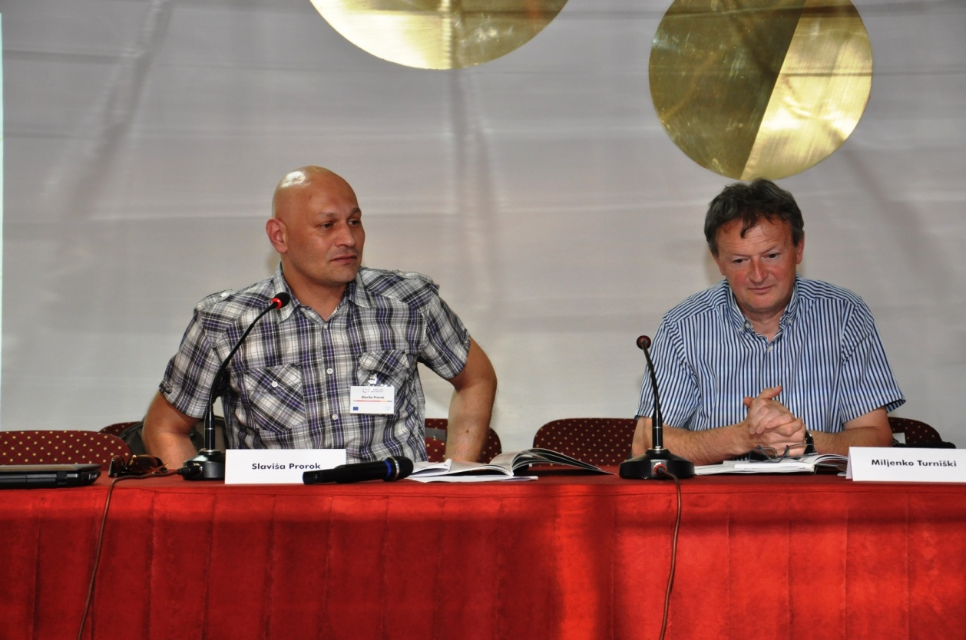

After the presentation of conclusions of both parallel panel sessions, Stanka Parac Damjanovic, regional programme coordinator for the South-eastern Europe from the Association of agencies of local democracy, has closed the working part of the conference on behalf of the leading partners. Two years ago, we have decided to embrace this joint project having in mind, as a regional network of civil society organisations, first of all, a need to try and give our possible answers to the challenges related to the position, status and functioning of the civil society organisations, but primarily on the local level. The memorandum of cooperation between governmental and nongovernmental sectors served us as a general framework for two key issues: one is a possibility to check to what extent and in which form the memorandum is being implemented where it should be implemented – in the local communities, and the other important task we wanted to position as a goal within this project is the possibility to compare our experiences here in the region, where we jointly share our experiences related to our overall efforts of coming closer to the European values, European integrations and in the process in which people and individuals, mostly in local communities, are hardly getting around. The third motive was to use exchange of experiences and evaluation of the situation at the local level to attempt to position a process in these two years. This process we call the learning (or maturing) process of the civil society organisations.
Eight organisations for which we have decided to be the partners in the project, but not only partners, but leaders of the activities, have learnt how to mature as a nongovernmental organisation in their local community to become a relevant correspondent to their local authorities, the one that is respected and who can start legitimate activities for the benefit of their local community. Local organisations of the civil society in Bosnia and Herzegovina, together with those from the region, will not offer solutions, but will jointly seek the most efficient, best models, tools to educate ourselves, as the civil society organisations, and simultaneously strengthen our capacities. The civil society organisations in the region still miss the true position at the level their deserve it. We think that we deserve much more, but we are still lacking adequate recognition by the authorities, political protagonists and decision-makers. This memorandum we all signed today is, first of all, the proof of our maturity as organisations that started this with the aim to continue cooperation. At the same time, this memorandum opens the space for such initiative, which is primarily dedicated to good local management and principles of transparency, and, at the same time, development of local communities in this region, to be joined by some other organisations. As a network of organisations, we have the possibility to spread this idea and I hope this will be joined in a short period, because we already have certain initiatives in this field and have organisations from Montenegro, and we are working on having similar organisations from Macedonia join. Another important characteristic, and I think it is a huge space providing organised, systematic work of the organisations of civil society from the local level, is the system of local self-governance, effective functioning of local self-governments, in accordance with the European values, European standards of good management on one, and on the other hand nearing of local communities to the European Union and the idea of European integration of our countries and also the regional approach. It is sure that once Croatia enters into the European Union, the organisations working on these issues will become a very important resource for us all and it is for certain that we will be able to participate in these activities.
Another important thing to say is that besides our wish for the local self-governments to be our natural allies, a lot needs to be done to have that in reality, but at the same time we think that the European Union is also our natural ally. In this period of the IPA 2014-2020 planning, we will really try to participate as agile as possible in the process of consultations for this programme and not only consultations, but also including our organisations in this programme. I think that over these two years, and this is our intention for the future, too, our goal is to create a triangle of civil society organisations acting at the local level, local self-governments and their development strategies with the European Union directly, or through the Delegation of the European Union in our countries. in this sense, we also consider to be important the fact that over these two years we have managed to achieve a very constructive and creative cooperation with the colleagues from the TACSO programme in Bosnia and Herzegovina and in the region, but also the TACSO offices in other countries and we consider them our natural partners in this process of strengthening civil society organisations for this very complex and very important mission they have. This is the democratic potential at the local level. Without it, it will be hard with our decision-makers, to present the fundament of the necessary capacities for building of democracy in our countries, democratic systems and institutions, because we will not be able to progress towards the European Union without those institutions.

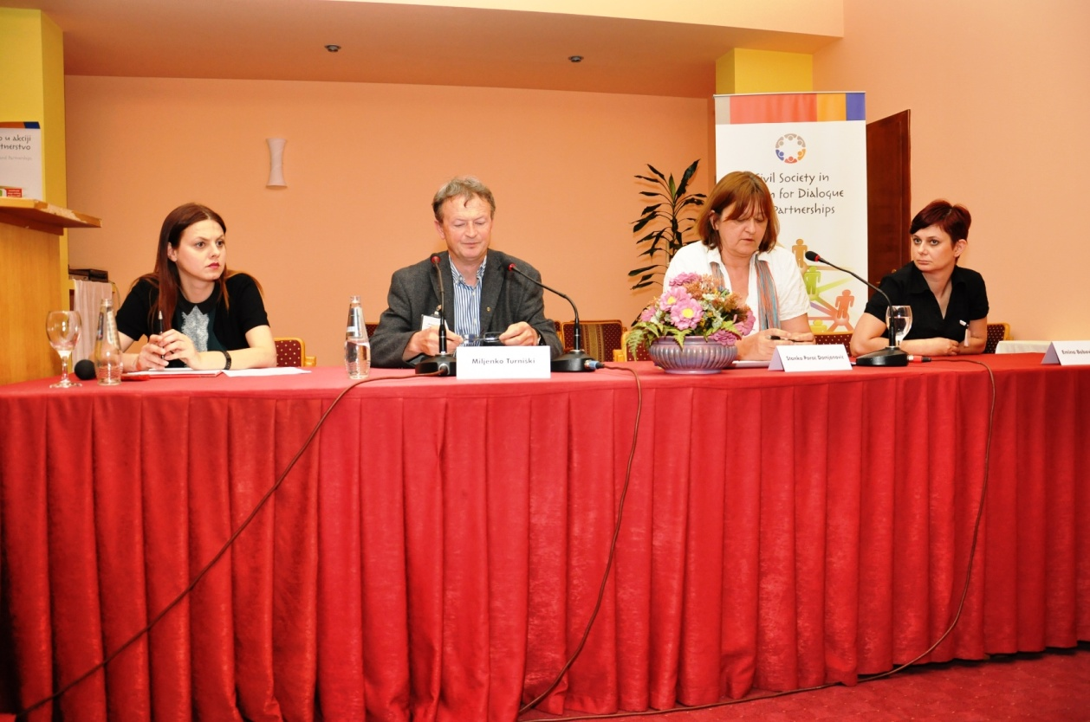

NGO FAIR
On the second day of the conference, there were three thematic round tables. The first one, titled “Development of local democracy and participation of citizens in the decision-making” which was moderated by Ms. Sefika Muratagic from the Kljuc buducnosti organisation from Kljuc. During the round table it was stated that the democratisation processes, when talking about inclusion of citizens in the decision-making processes in the region, are still on a low level. The citizens have not been motivated, informed and also not educated to take larger participation in the given processes and to make a more significant impact on the decision making processes relevant for their communities.

Recommendations:
Strengthening capacities of both governmental and nongovernmental sector, and networking of NGOs to contribute to democratisation of these processes through:
- initiation of the implementation of the agreement between government and NGO sector at the local level and activities on its modification and amendments;
- modifications and amendments of the Law on Local Self-governance in view of giving a higher significance to the units of local self-governance at the local level (district units);
- higher engagement of the NGO sector by the governmental institutions in terms of informing and education of citizens.

The second round table about “Gender Equality” was moderated by Mirjana Penava from the Forma F organisation from Mostar. Five nongovernmental organisations took part in this round table:
- UG „Sigurno mjesto“ Zavidovici (Arminka Memisevic)
- UG „Mala sirena“ Zavidovici (Sabina Mujkic)
- LDA Zavidovici (Jasna Zvekic)
- UG „Brijeski pleter“ Siroki Brijeg (Sanijela Matkovic, president of the Commission for Gender Equality at the Municipal Council of Siroki Brijeg)
- LDA Mostar (Dzenana Dedic, director)

As the other two thematic round tables, this one had the goal for the nongovernmental organisations to present their missions and activities, to analyse the situation related to gender equality in the municipalities they came from, and to provide information through exchange of experiences and best practices on how to improve the work of the associations and how to integrate the concept of gender equality into the local policies. During the round table, a lot of problems were identified when talking about the advocacy for gender equality, i.e. equal opportunities for women and men. Some of the problems which were identified by the participants are:
- Due to lack of understanding of the gender concept, when creating municipal / city budgets, no account it paid to the needs of men and women (not gender sensitive);
- Political parties only declaratively support equal opportunities and they implement international and local legislative only when they have to (e.g. to verify the lists of candidates for elections, and in similar cases);
- In some professions, e.g. journalism, under the excuse of “protecting the gentler gender, and the duties in the family”, women are being deprived from engagements through which the female journalists, thanks to their eloquence, could be recognised or popular in public;
- The relationship of the society in general towards divorced women (unlike to the opinion to divorced men) is inhuman;
- In some areas of Bosnia and Herzegovina patriarchate is on the rise, along with new trends, not specific for Bosnia and Herzegovina, e.g. marriage with more than one woman;
- Women taking case of children or family members with disability are overburdened, and additionally exhausted with the poor economic status;
- Local programmes and policies do not have mechanisms to help women and men to equally enjoy their rights and have equal opportunities in all spheres of life.

The very fact that there were no men participating at this round table, but only five women, speaks about the overall conclusion of the group that we are indeed a male society and that we need a lot of energy to preserve the minimum of equality.

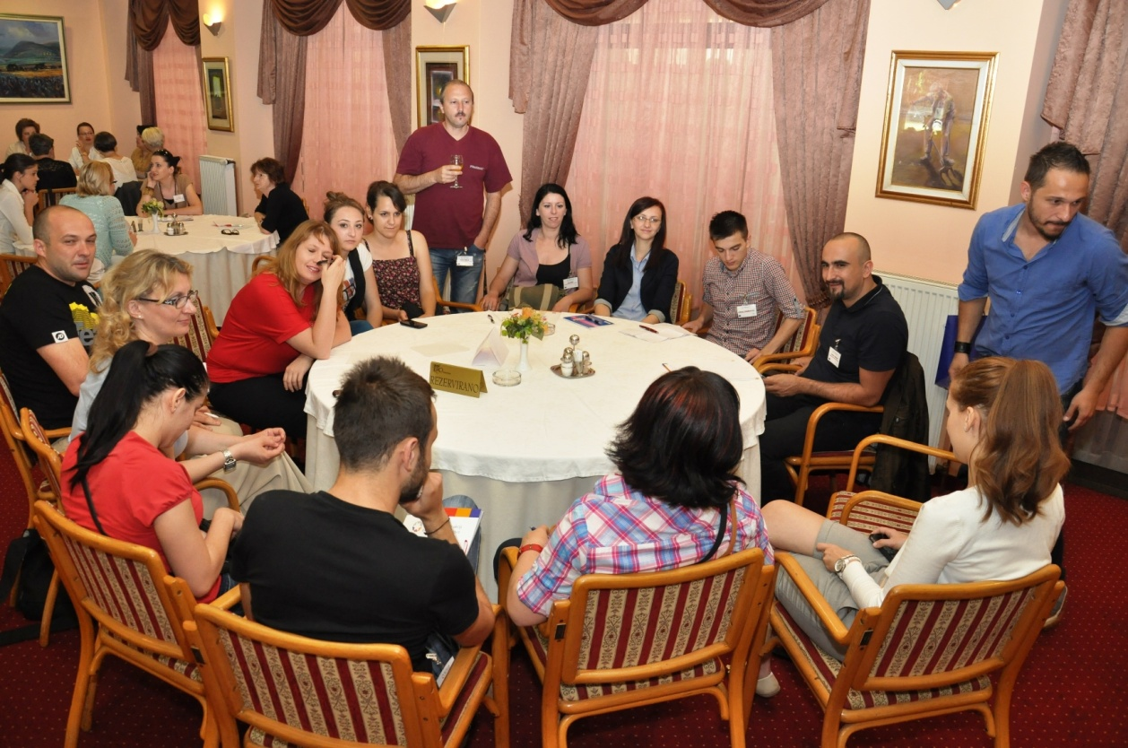

The third round table, “Strengthening of the youth”, was moderated by Mr. Jasmin Jasarevic from the Proni organisation from Brcko. During the discussion, the participants touched upon the following topics:
- Internal, i.e. programmes of youth exchange within Bosnia and Herzegovina (because it is known that youth does not cross over the entity border, or that rarely happens)
  - Exchange programmes for youth with neighbouring countries and the EU countries;
- Legal regulations and youth policies;
- Institutional representation of the issues of youth at local and state levels;
- Professionalization and standardisation of youth work as an important segment in the work with youth;
- Formal and informal education;
- Activities of youth organisations.
Conclusions and recommendations from the round table “Strengthening of the youth”:
- It is needed to initiate and support programmes providing mobility of the youth within the country with the specific focus on programmes of youth exchange working on overcoming ethnic barriers and to support youth to volunteer or start youth programmes with the countries in the neighbourhood or the EU countries (with accent on the programme Youth in Action, i.e. EVS – European Volunteering Service);
- It is needed to pass laws for youth at all levels of Bosnia and Herzegovina, as well as youth policies and strategies and to apply those in practice.
- Establishing of the council for youth at the municipal and other levels of authority, and their strengthening present the priority for the youth in Bosnia and Herzegovina to have an impact on policies and laws that are directly related to them.
- Professionalise the profession of a “youth worker”, and establish standards in work with the youth at all levels in Bosnia and Herzegovina in order to raise the level of quality of work with the young and to ensure quality of experiences and knowledge / skills the young gain through different programmes for youth.
- Formal education needs to be complemented with informal education for youth providing opportunities to the young to solve existential problems or to have a larger impact on raising self-confidence and awareness among the youth.
- Youth organisations have good programmes, but they are faced with the issue of sustainability of the organisations and lack of quality / educated / experienced staff, who are leaving organisations in order to solve some of their own existential problems.

Press conference
The press conference held at the end of the conference activities, and before the NGO fair was held, the media was addressed by Sefika Muratagic, from the Kljuc buducnosti from Kljuc, who moderated the round table 1 “Development of local democracy and participation of citizens in the decision-making”, Mirjana Penava from the Forma F organisation from Mostar, who moderated the round table 2 “Equality of Genders”, Jasmin Jasarevic from Proni organisation from Brcko, who moderated the round table 3 “Strengthening of the Youth”, Senada Sadovic on behalf of the City of Mostar and Dzenana Dedic on behalf of the host organisation, the Agency of Local Democracy of Mostar.

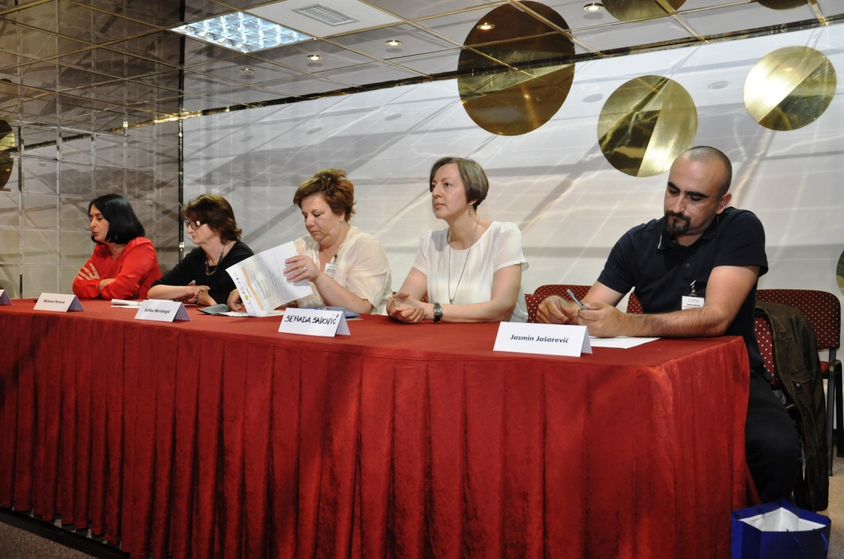

The NGO Fair was organised after the press conference as a possibility for all organisations that participated at the conference to present their activities and use this opportunity for networking with organisations of similar profile, coming from other parts of Bosnia and Herzegovina. The fair was opened by Ms. Senada Sadovic from the department of community activities of the City of Mostar.

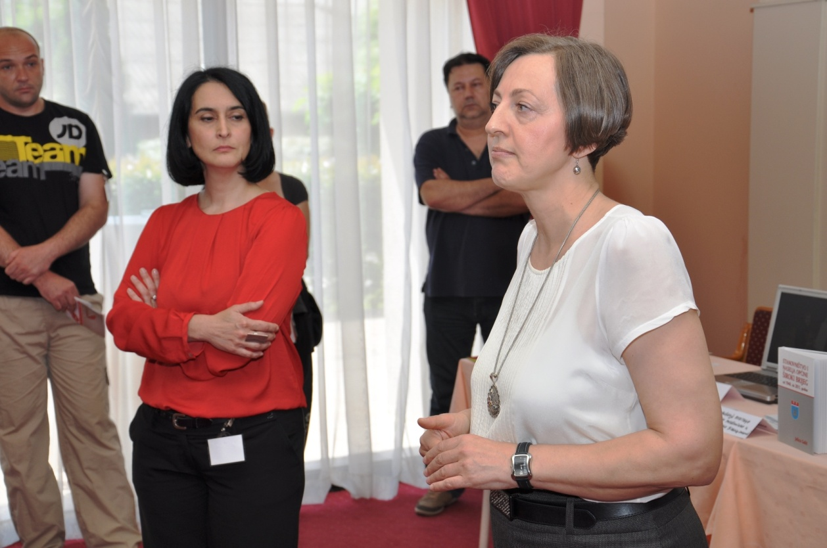

Twenty-nine organisations presented their work at the Fair:
- UG Forum građana Tuzle
- Asocijacija „Margina“ Tuzla
- Udruženje žena „Rudarke“ Ljubija
- UG „Berek“ Prijedor
- UG DON Prijedor
- Udruženje za pomoć mentalno nedovoljno razvijenim licima Prijedor
- UG Centar za lokalni razvoj Breza
- Ekološko društvo „20. Mart 1990.“ Breza
- Omladinski centar „Desnek“ Breza
- Demokratski centar „Nove nade“ Bihać
- UG Teatar mladih Bihać
- UG Novi put, Bihać
- UG Žene sa Une Bihać
- Agencija lokalne demokratije Zavidovići
- UG Ceker Zavidovići
- UG Sigurno mjesto Zavidovići
- UG Mala sirena
- UG Agencija lokalne demokratije Osijek
- UG Agencija lokalne demokratije Subotica
- UG Agencija lokalne demokratije Mostar
- Asocijacija agencija lokalne demokratije (ALDA)
- UG Vijeće mladih Grada Mostara
- UG Forma F Mostar
- UG Proni Brčko
- UG Briješki pleter
- Udruženje građana „Ruka ruci“ Bihać
- UG Edukativni centar roma
- UG Agencija lokalne demokratije Prijedor
- UG Centar za lokalni razvoj Breza

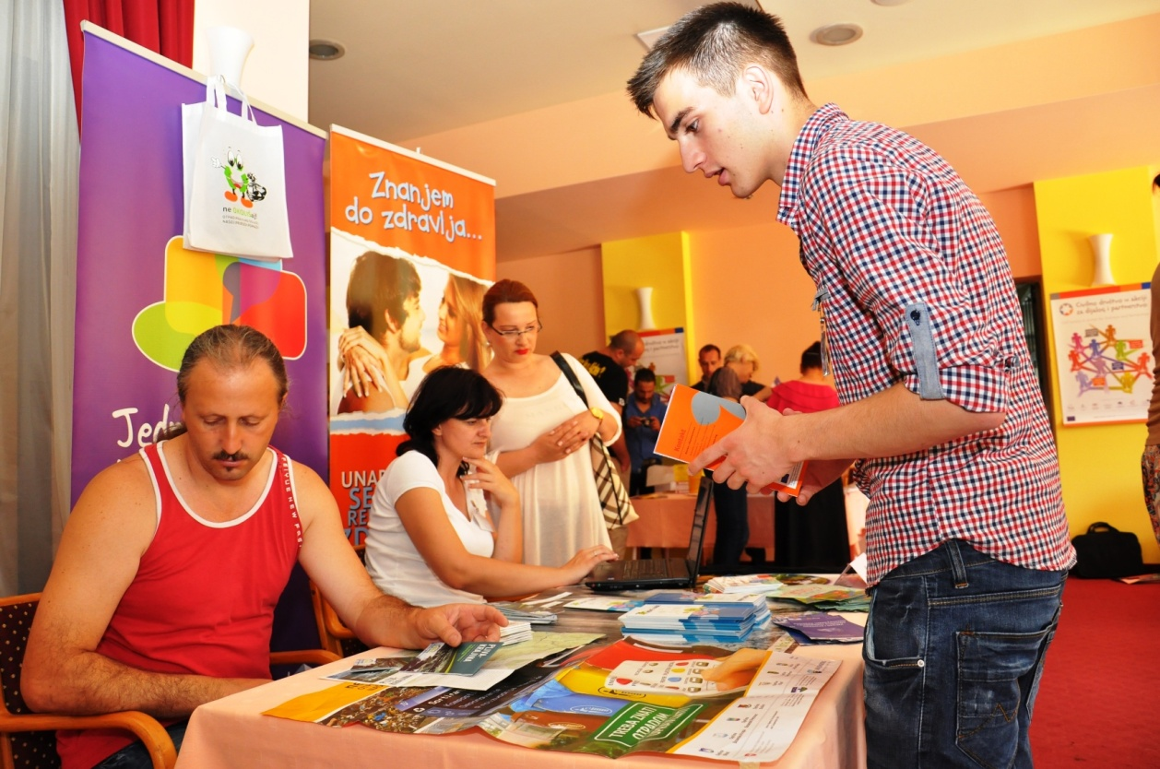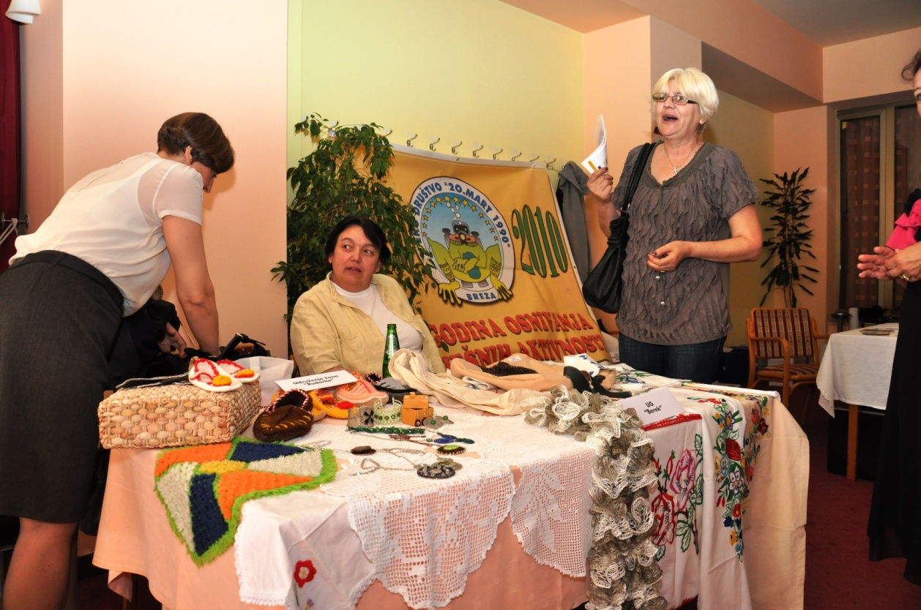

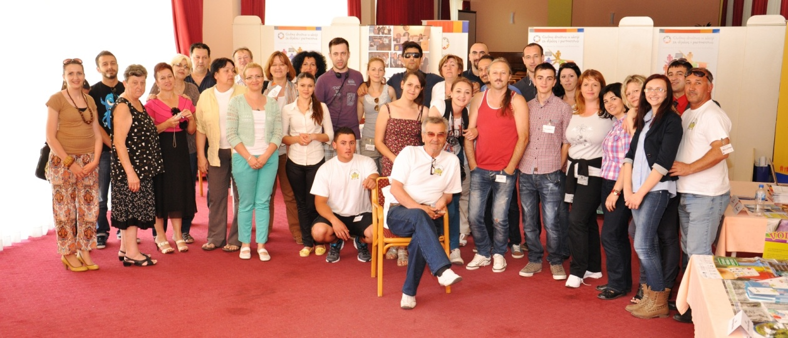

Forester, S. 2013 Report on Progress Achieved af ther the Becici Conference, held in Feburary 2011: Cooperation between local governments and the CSOs in the Western Balkans and Turkey, accessed on the 28th of May 2013; <http://www.tacso.org/doc/doc_progress_report2013ba.pdf>
Centre for Promotion of Civil Society (2011). “Towards participative local self-government: analysis, application of the Agreement between municipal council, municipal mayor and nongovernmental organisations in Bosnia and Herzegovina”. Available at: <http://www.civilnodruštvo.ba>

